Marlon Louis

Prof. Heller

CSCI331

Group 4

20 Individual Queries

**SIMPLE 1:** Find all customers who placed orders from US and the name and region of the employee who serviced them

**Standard View:**

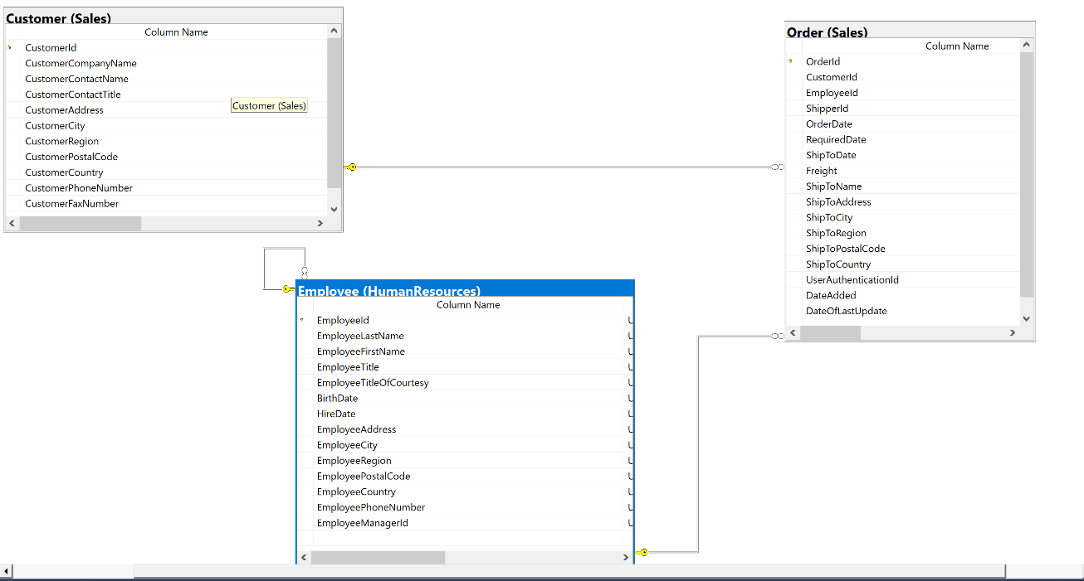

**Key View:**

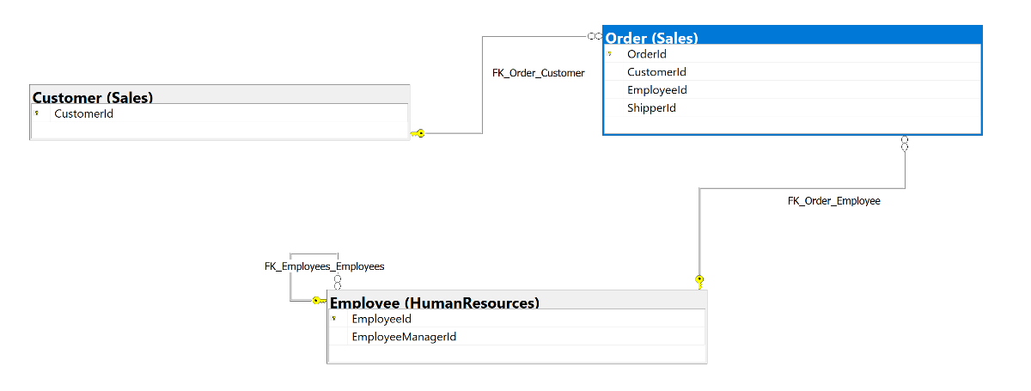

**Columns from tables:**

|  |  |
| --- | --- |
| **Table Name** | **Column Names** |
| Sales.Customer | CustomerCountry  CustomerId  CustomerContactName |
| HumanResources.Employee | EmployeeFirstName  EmployeeId |

**Order by**

|  |  |  |
| --- | --- | --- |
| **Table Name** | **Column Name** | **Sort Order** |
| Sales.Customer | CustomerId | ASC |
| HumanResources.Employee | EmployeeId | ASC |

**Solution Without JSON:**

USE Northwinds2020TSQLV6;

SELECT c.CustomerCountry

,c.CustomerId

,c.customerContactName

,e.EmployeeFirstName

,e.EmployeeId

FROM Sales.Customer AS C

INNER JOIN Sales.[Order] AS O ON c.CustomerId = o.CustomerId

INNER JOIN HumanResources.Employee AS E ON e.EmployeeId = o.EmployeeId

WHERE c.CustomerCountry = N'USA'

ORDER BY c.CustomerId

,e.EmployeeId

**Solution with JSON:**

USE Northwinds2020TSQLV6;

SELECT c.CustomerCountry

,c.CustomerId

,c.customerContactName

,e.EmployeeFirstName

,e.EmployeeId

FROM Sales.Customer AS C

INNER JOIN Sales.[Order] AS O ON c.CustomerId = o.CustomerId

INNER JOIN HumanResources.Employee AS E ON e.EmployeeId = o.EmployeeId

WHERE c.CustomerCountry = N'USA'

ORDER BY c.CustomerId

,e.EmployeeId

FOR JSON PATH, ROOT(‘Output’), INCLUDE_NULL_VALUES;

**Sample Output (122 results returned):**

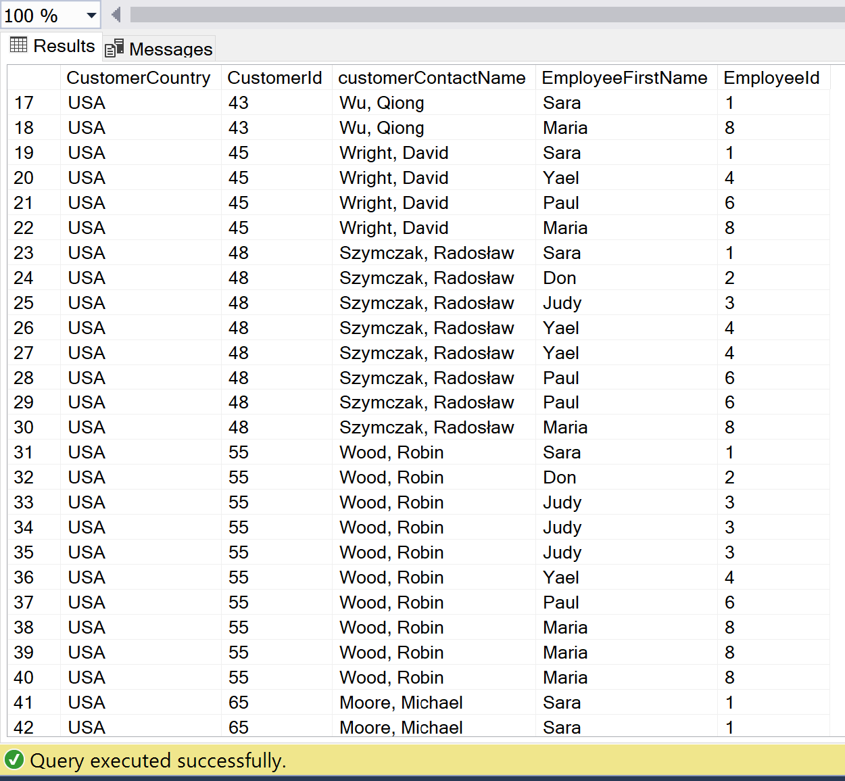

**Sample JSON Output (122 results returned):**

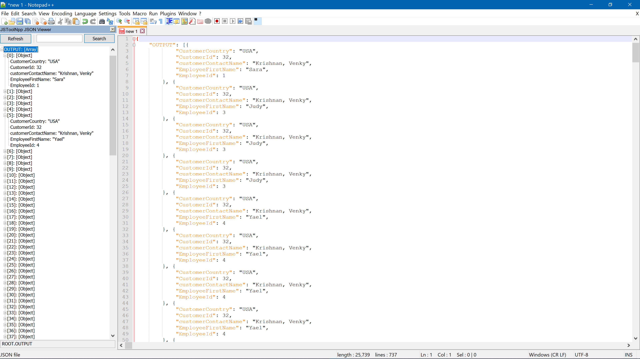

**SIMPLE 2:** find all product names, price, and the name of the product supplier

**Standard View:**

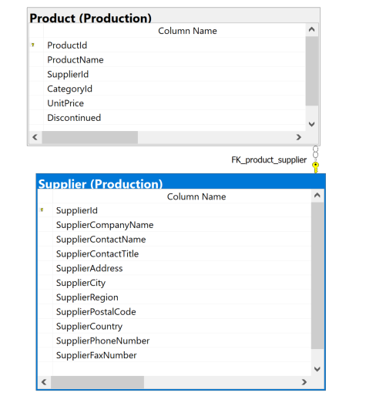

**Key View:**

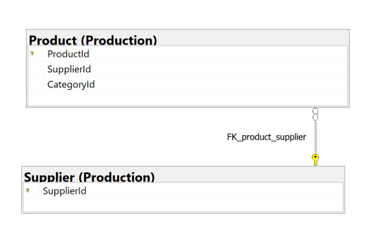

**Columns from tables:**

|  |  |
| --- | --- |
| **Table Name** | **Column Name** |
| Production.Product | ProductName  UnitPrice |
| Production.Supplier | SupplierContactName  SupplierContactTitle  SupplierCompanyName |

**Order By:**

|  |  |  |
| --- | --- | --- |
| **Table Name** | **Column Name** | **Sort Order** |
| Production.Product | UnitPrice | DESC |

**Solution without JSON:**

USE Northwinds2020TSQLV6;

SELECT p.ProductName

,p.UnitPrice

,s.SupplierContactName

,s.SupplierContactTitle

,s.SupplierCompanyName

FROM Production.Product AS P

INNER JOIN Production.Supplier AS S ON p.SupplierId = s.SupplierId

ORDER BY p.UnitPrice DESC

**Solution with JSON:**

USE Northwinds2020TSQLV6;

SELECT p.ProductName

,p.UnitPrice

,s.SupplierContactName

,s.SupplierContactTitle

,s.SupplierCompanyName

FROM Production.Product AS P

INNER JOIN Production.Supplier AS S ON p.SupplierId = s.SupplierId

ORDER BY p.UnitPrice DESC

FOR JSON PATH, ROOT('Simple 2 Output'), INCLUDE_NULL_VALUES;

**Sample Output (77 results returned):**

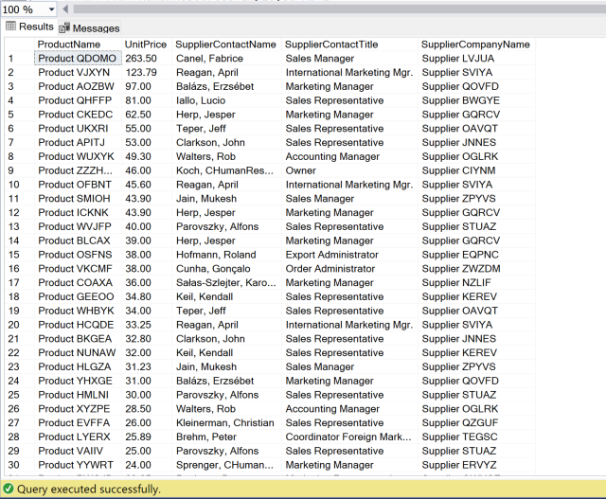

**Sample JSON Output (77 results returned):**

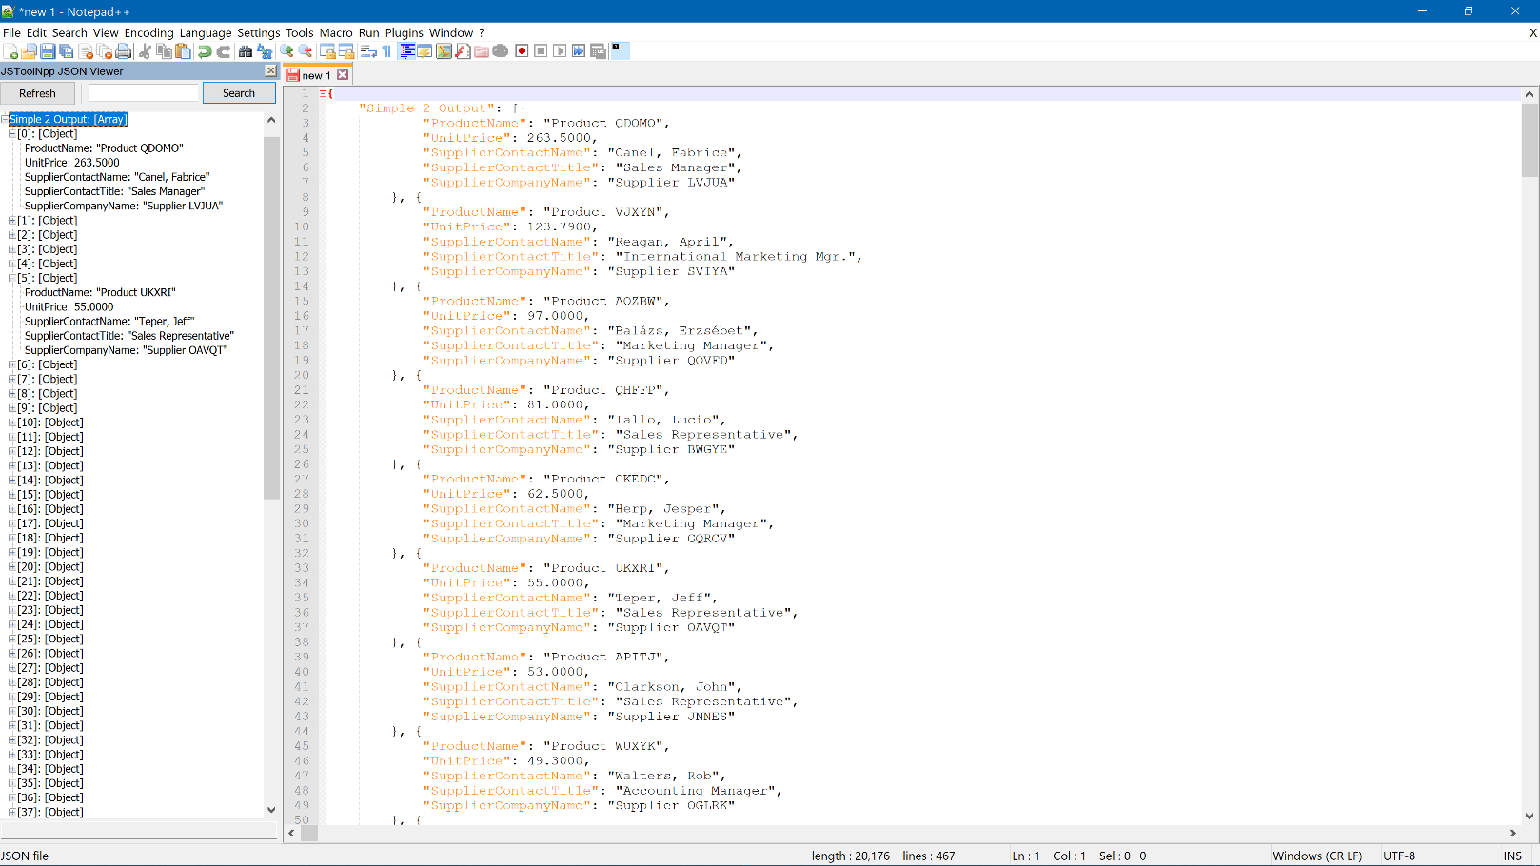

**SIMPLE 3:** list all employee titles and their current pay

**Standard View:**

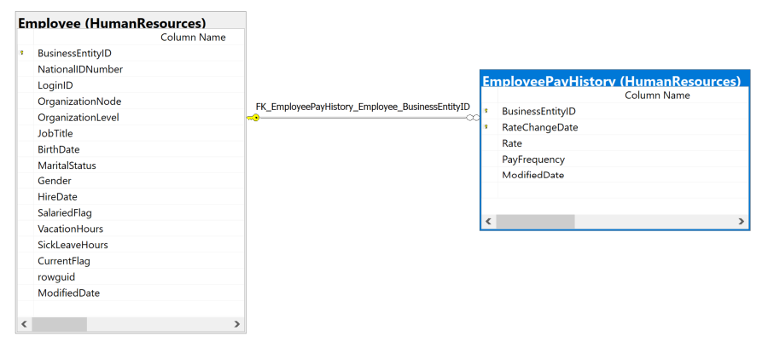

**Key View:**

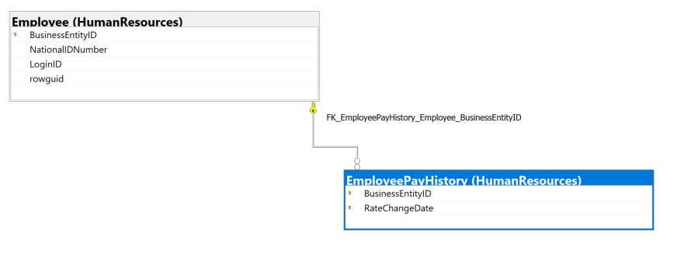

**Columns from tables:**

|  |  |
| --- | --- |
| **Table Name** | **Column Name** |
| HumanResources.Employee | BusinessEntityId  JobTitle |
| HumanResources.EmployeePayHistory | Rate |

**Order By:**

|  |  |  |
| --- | --- | --- |
| **Table Name** | **Column Name** | **Sort Order** |
| HumanResources.EmployeePayHistory | HourlyWage | DESC |

**Solution without JSON:**

USE AdventureWorks2017;

SELECT e.BusinessEntityID

,e.JobTitle

,p.Rate AS HourlyWage

FROM HumanResources.Employee AS E

INNER JOIN HumanResources.EmployeePayHistory AS P ON e.BusinessEntityID = p.BusinessEntityID

ORDER BY HourlyWage DESC

**Solution with JSON:**

USE AdventureWorks2017;

SELECT e.BusinessEntityID

,e.JobTitle

,p.Rate AS HourlyWage

FROM HumanResources.Employee AS E

INNER JOIN HumanResources.EmployeePayHistory AS P ON e.BusinessEntityID = p.BusinessEntityID

ORDER BY HourlyWage DESC

FOR JSON PATH, ROOT('Simple 3 Output'), INCLUDE_NULL_VALUES;

**Sample Output (316 results returned):**

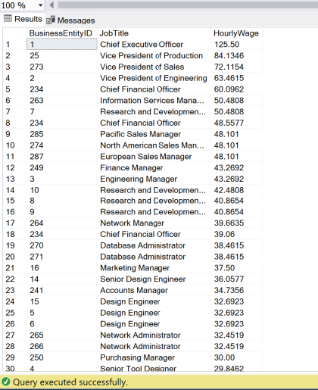

**Sample JSON Output (316 results returned):**

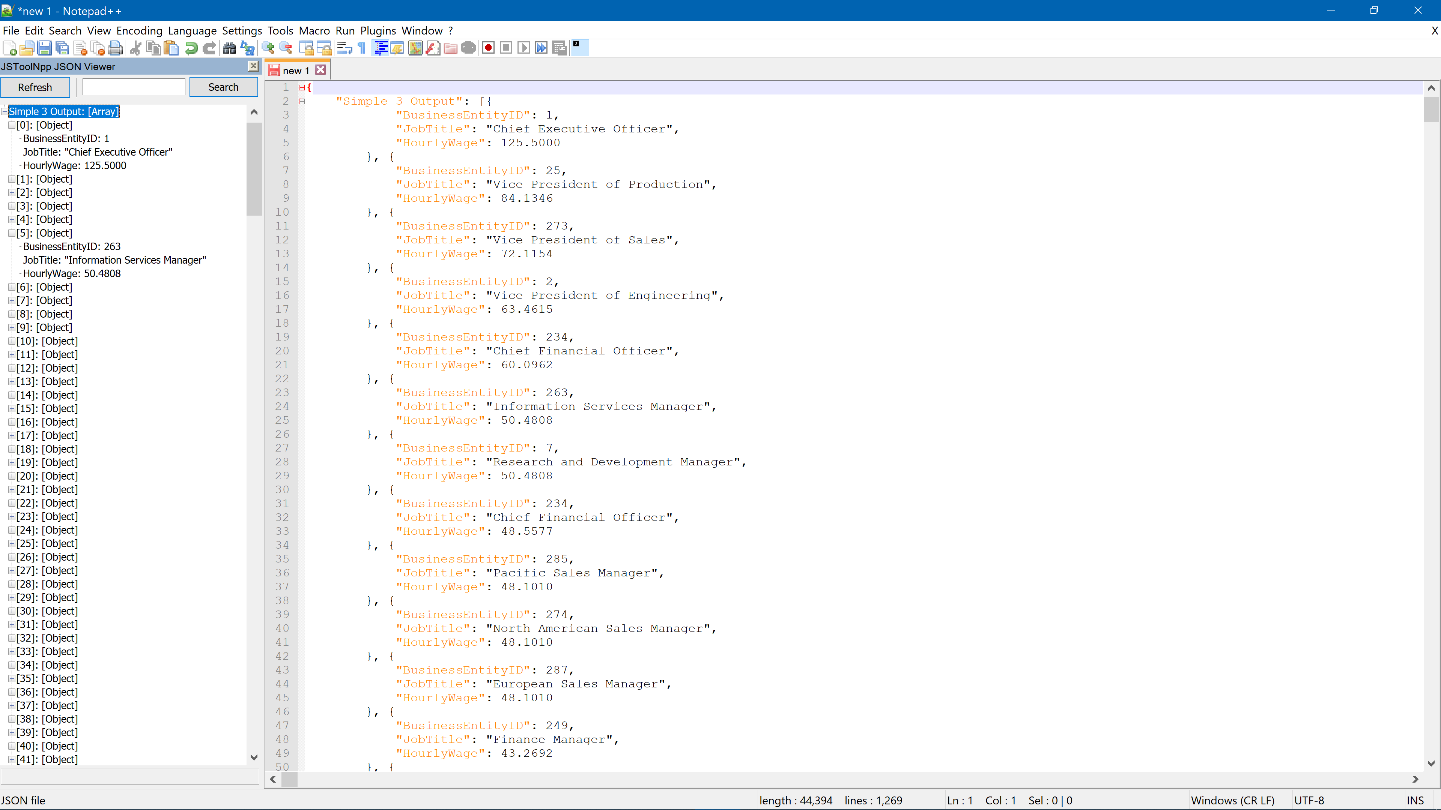

**SIMPLE 4:** List all employee names and their phone number

**Standard View:**

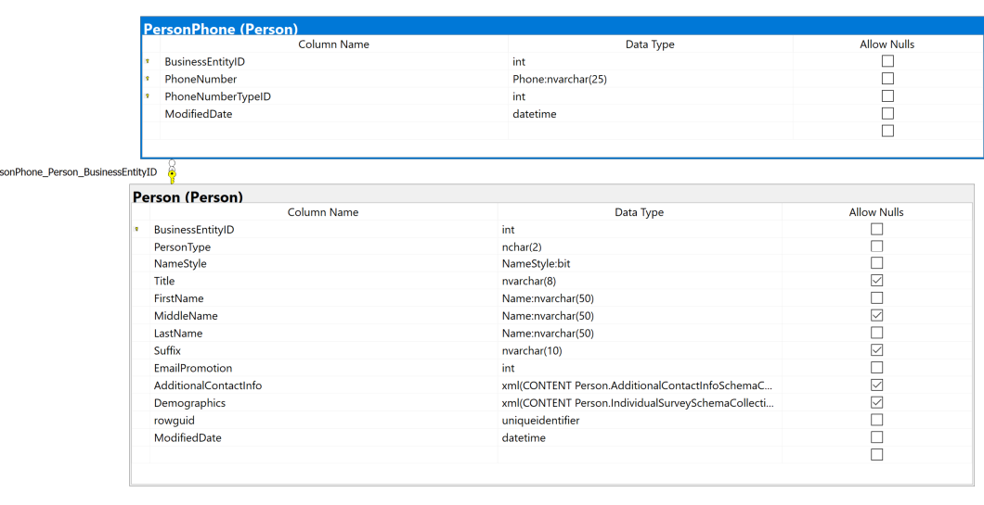

**Key View:**

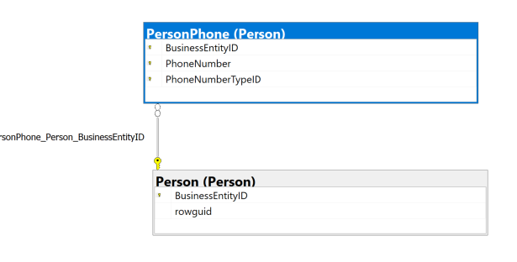

**Columns from tables:**

|  |  |
| --- | --- |
| **Table Name** | **Column Name** |
| Person.Person | FirstName  LastName |
| Person.PersonPhone | PhoneNumber |

**Order By:**

|  |  |  |
| --- | --- | --- |
| **Table Name** | **Column Name** | **Sort Order** |
| Person.PersonPhone | BusinessEntityId | ASC |

**Solution without JSON:**

USE AdventureWorks2017;

SELECT n.FirstName

,n.LastName

,p.PhoneNumber

FROM Person.PersonPhone AS p

INNER JOIN Person.Person AS n ON p.BusinessEntityID = n.BusinessEntityID

ORDER BY p.BusinessEntityID

**Solution with JSON:**

USE AdventureWorks2017;

SELECT n.FirstName

,n.LastName

,p.PhoneNumber

FROM Person.PersonPhone AS p

INNER JOIN Person.Person AS n ON p.BusinessEntityID = n.BusinessEntityID

ORDER BY p.BusinessEntityID

FOR JSON PATH, ROOT('Simple 4 Output'), INCLUDE_NULL_VALUES;

**Sample Output (19,972 results returned):**

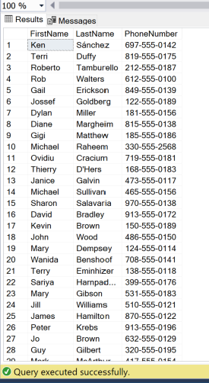

**Sample JSON Output (19,972 results returned):**

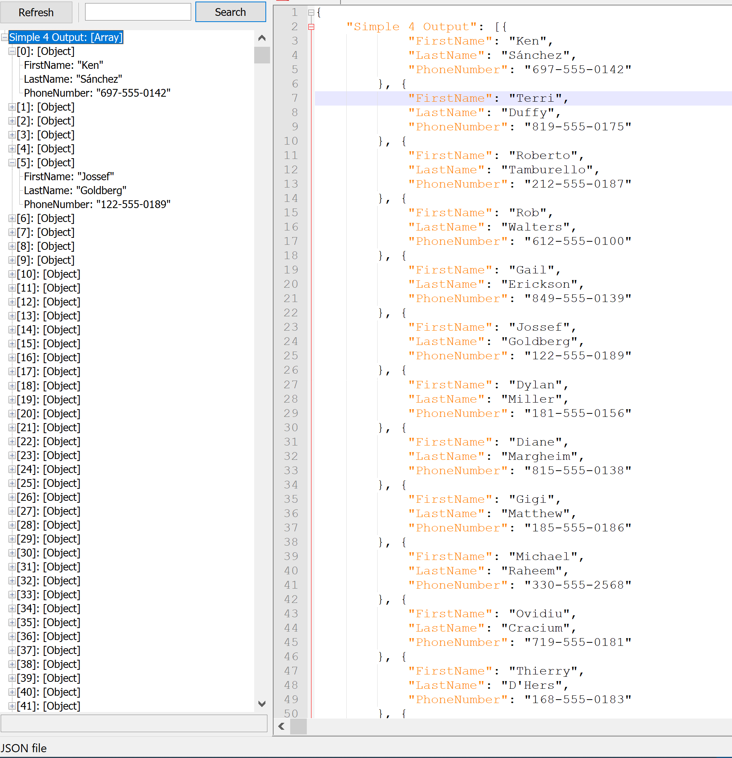

**SIMPLE 5:** listing sales people in order from previous year earnings

**Standard View:**

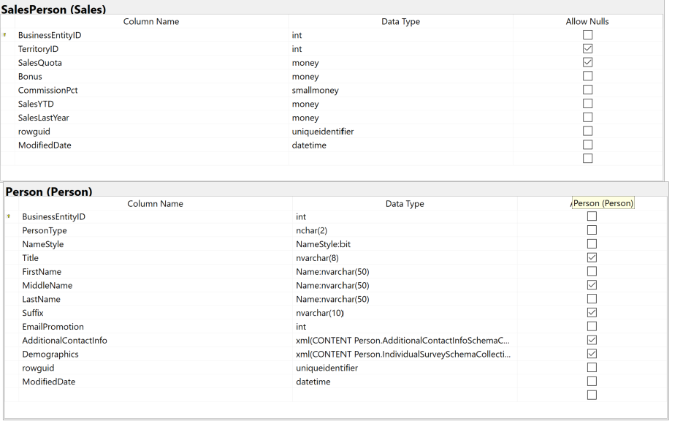

**Key View:**

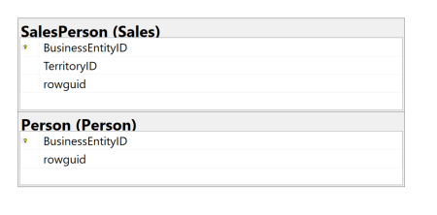

**Columns from tables:**

|  |  |
| --- | --- |
| **Table Name** | **Column Name** |
| Person.Person | BusinessEntityId  FirstName  LastName |
| Sales.SalesPerson | SalesYTD  SalesLastYear |

**Order By:**

|  |  |  |
| --- | --- | --- |
| **Table Name** | **Column Name** | **Sort Order** |
| Sales.SalesPerson | SalesLastYear | DESC |

**Solution without JSON:**

USE AdventureWorks2017;

SELECT p.BusinessEntityID

,p.FirstName

,p.LastName

,s.SalesYTD

,s.SalesLastYear

FROM Sales.SalesPerson AS s

INNER JOIN Person.Person AS p ON s.BusinessEntityID = p.BusinessEntityID

ORDER BY SalesLastYear DESC

**Solution with JSON:**

USE AdventureWorks2017;

SELECT p.BusinessEntityID

,p.FirstName

,p.LastName

,s.SalesYTD

,s.SalesLastYear

FROM Sales.SalesPerson AS s

INNER JOIN Person.Person AS p ON s.BusinessEntityID = p.BusinessEntityID

ORDER BY SalesLastYear DESC

FOR JSON PATH, ROOT('Simple 5 Output'), INCLUDE_NULL_VALUES;

**Sample Output (17 results returned):**

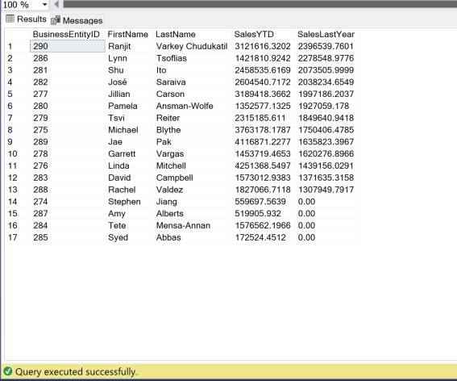

**Sample JSON Output (17 results returned):**

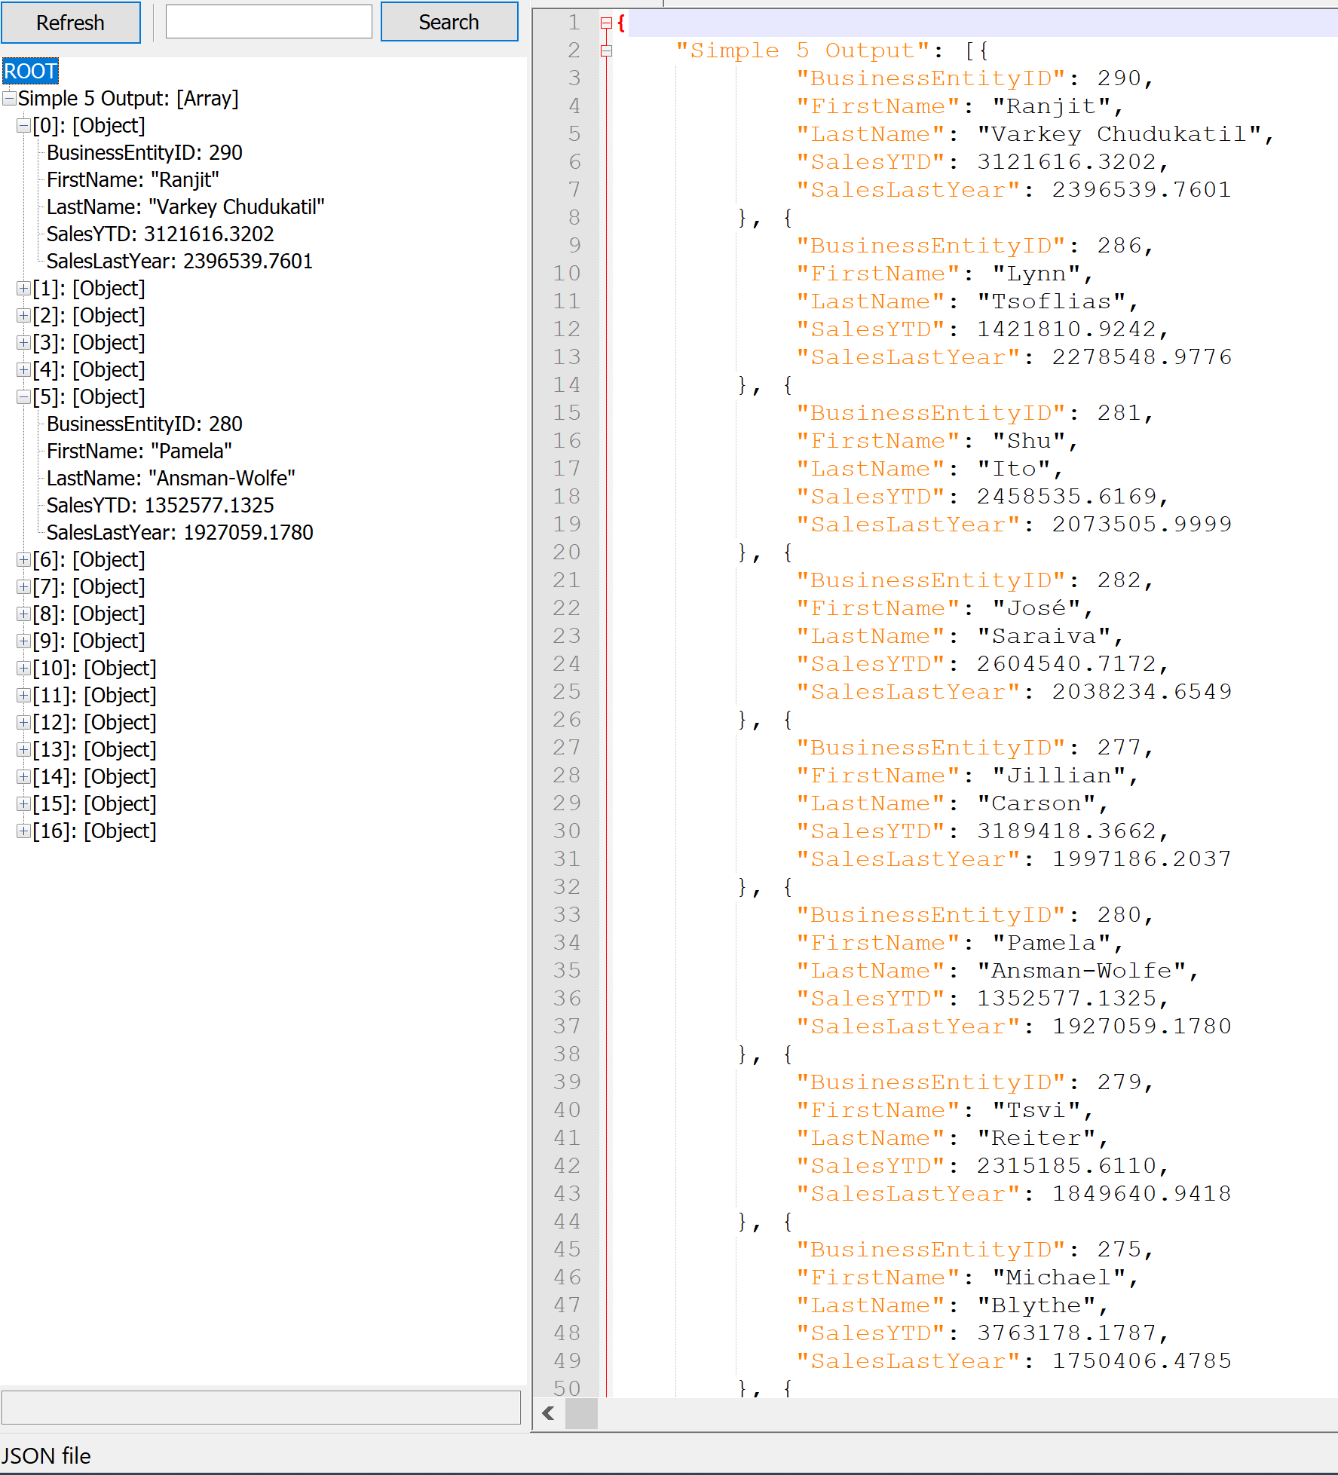

**MEDIUM 1:** find the product name and Id that was purchased the most amongst all customers

**Standard View:**

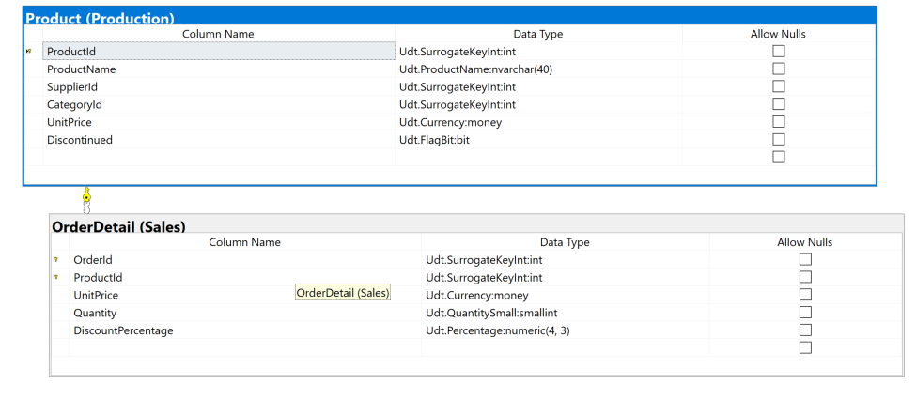

**Key View:**

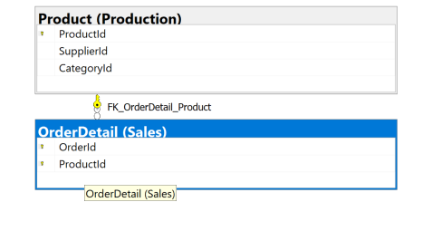

**Columns from tables:**

|  |  |
| --- | --- |
| **Table Name** | **Column Name** |
| Production.Product | ProductName  ProductId |
| Sales.OrderDetails | ProductId |

**Order By:**

|  |  |  |
| --- | --- | --- |
| **Table Name** | **Column Name** | **Sort Order** |
| Sales.OrderDetails | NumSales | DESC |

**Solution without JSON:**

USE Northwinds2020TSQLV6;

SELECT o.ProductId

,p.ProductName

,p.UnitPrice

,COUNT(*) AS numSales

FROM Sales.[OrderDetail] AS O

INNER JOIN Production.Product AS P ON o.ProductId = p.ProductId

GROUP BY o.ProductId

,p.ProductName

,p.UnitPrice

ORDER BY numSales DESC

**Solution with JSON:**

USE Northwinds2020TSQLV6;

SELECT o.ProductId

,p.ProductName

,p.UnitPrice

,COUNT(*) AS numSales

FROM Sales.[OrderDetail] AS O

INNER JOIN Production.Product AS P ON o.ProductId = p.ProductId

GROUP BY o.ProductId

,p.ProductName

,p.UnitPrice

ORDER BY numSales DESC

FOR JSON PATH, ROOT('Medium 1 Output'), INCLUDE_NULL_VALUES;

**Sample Output (77 results returned):**

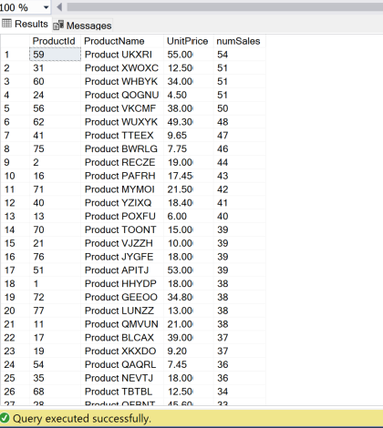

**Sample JSON Output (77 results returned):**

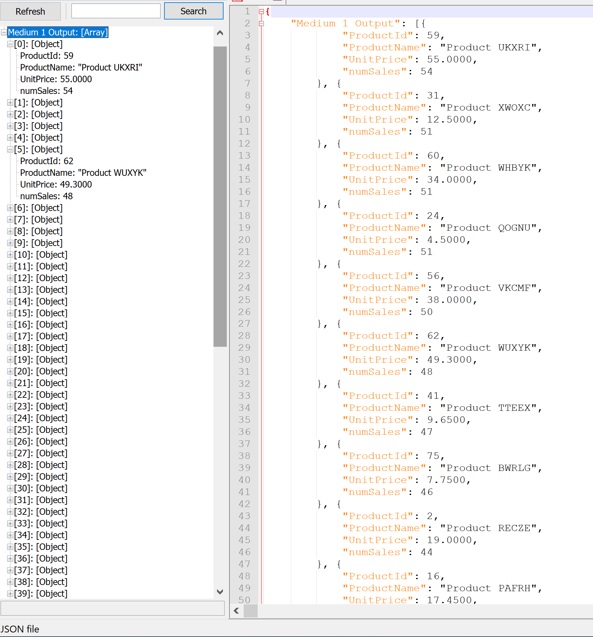

**MEDIUM 2:** This query lists the customers who spent the most on purchasing products.

**Standard View:**

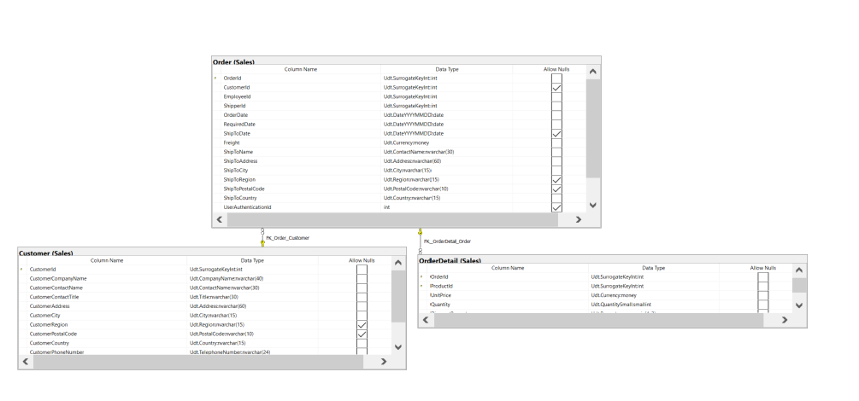

**Key View:**

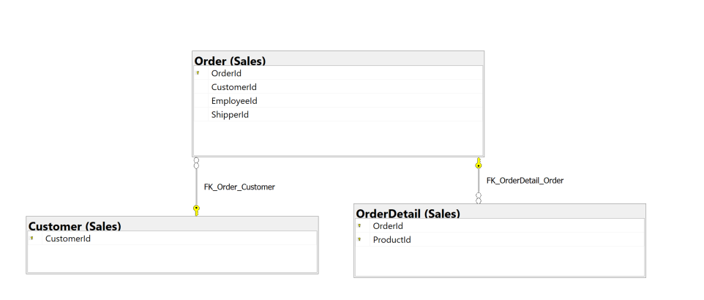

**Columns from tables:**

|  |  |
| --- | --- |
| **Table Name** | **Column Name** |
| Sales.Order | CustomerId |
| Sales.Customer | CustomerContactName |

**Order By:**

|  |  |  |
| --- | --- | --- |
| **Table Name** | **Colum Name** | **Sort Order** |
| Sales.OrderDetail | TotalSpent | DESC |

**Solution without JSON:**

USE Northwinds2020TSQLV6;

SELECT TOP 5 o.CustomerId

,c.CustomerContactName

,sum(d.UnitPrice * d.Quantity) AS totalSpent

FROM Sales.OrderDetail AS d

INNER JOIN Sales.[Order] AS o ON d.OrderId = o.OrderId

INNER JOIN Sales.Customer AS c ON o.CustomerId = c.CustomerId

GROUP BY o.customerId

,c.customerContactName

ORDER BY totalSpent DESC;

**Solution with JSON:**

USE Northwinds2020TSQLV6;

SELECT TOP 5 o.CustomerId

,c.CustomerContactName

,sum(d.UnitPrice * d.Quantity) AS totalSpent

FROM Sales.OrderDetail AS d

INNER JOIN Sales.[Order] AS o ON d.OrderId = o.OrderId

INNER JOIN Sales.Customer AS c ON o.CustomerId = c.CustomerId

GROUP BY o.customerId

,c.customerContactName

ORDER BY totalSpent DESC;

FOR JSON PATH, ROOT('Medium 2 Output'), INCLUDE_NULL_VALUES;

**Sample Output (5 results returned):**

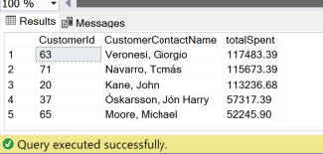

**Sample JSON Output (5 results returned):**

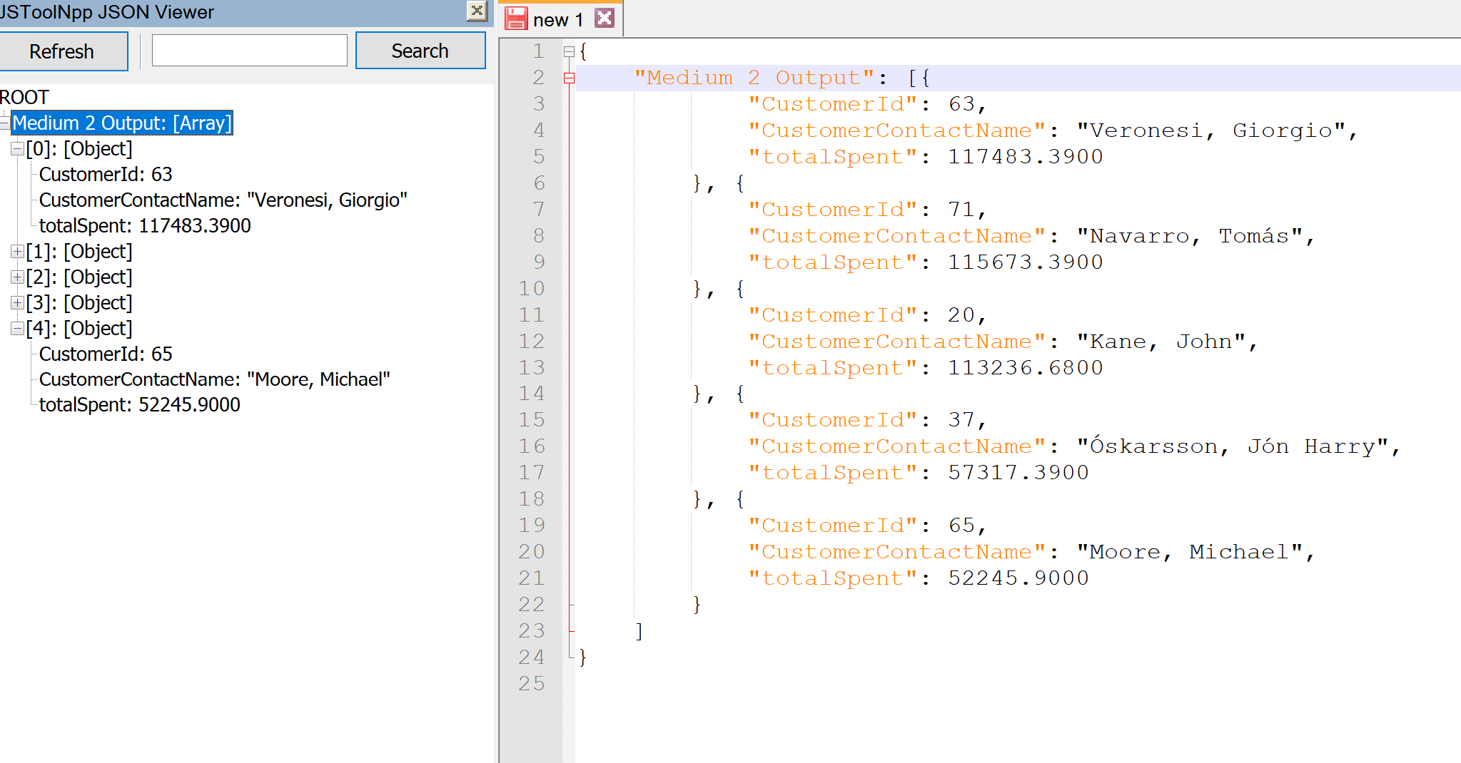

**MEDIUM 3:** This query finds the city where most customers reside and lists all customers who live there

**Standard View:**

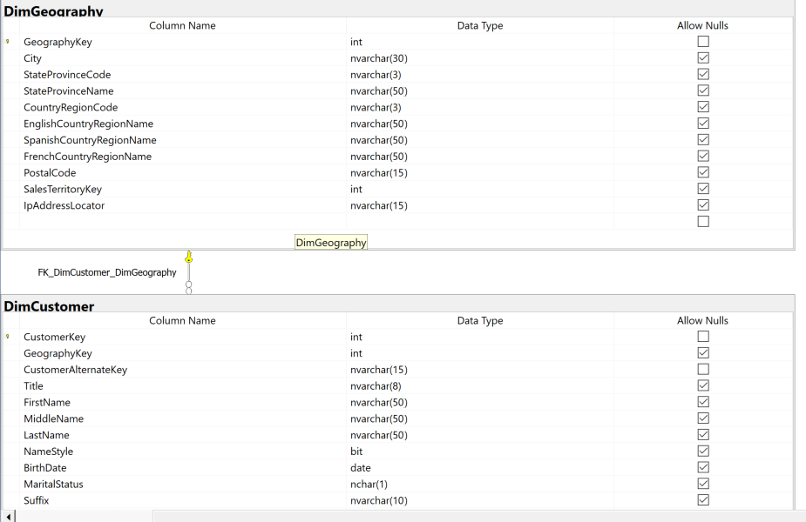

**Key View:**

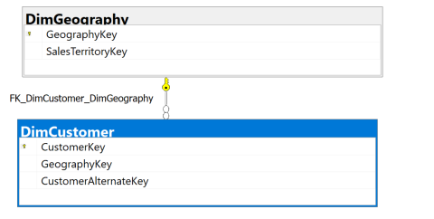

**Columns from tables:**

|  |  |
| --- | --- |
| **Table Name** | **Column Name** |
| Dbo.DimCustomer | FirstName  LastName  EmailAddress  BirthDate  Gender  YearlyIncome |
| Dbo.DimGeography | City |

**Order By:**

|  |  |  |
| --- | --- | --- |
| **Table Name** | **Column Name** | **Sort Order** |
| Dbo.DimCustomer | YearlyIncome | DESC |

**Solution without JSON:**

USE AdventureWorksDW2017;

SELECT g.city

,c.firstname

,c.lastname

,c.emailaddress

,c.birthdate

,c.gender

,c.yearlyincome

FROM dbo.dimCustomer AS c

INNER JOIN dbo.dimGeography AS g ON c.geographyKey = g.GEOGRAPHYkey

WHERE g.city = (

SELECT city

FROM (

SELECT TOP 1 g.city

,COUNT(*) AS custLocal

FROM dbo.dimCustomer AS c

INNER JOIN dbo.dimGeography AS g ON g.geographyKey = c.geographyKey

GROUP BY g.city

ORDER BY custLocal DESC

) AS gu

)

ORDER BY yearlyincome DESC

**Solution with JSON:**

USE AdventureWorksDW2017;

SELECT g.city

,c.firstname

,c.lastname

,c.emailaddress

,c.birthdate

,c.gender

,c.yearlyincome

FROM dbo.dimCustomer AS c

INNER JOIN dbo.dimGeography AS g ON c.geographyKey = g.GEOGRAPHYkey

WHERE g.city = (

SELECT city

FROM (

SELECT TOP 1 g.city

,COUNT(*) AS custLocal

FROM dbo.dimCustomer AS c

INNER JOIN dbo.dimGeography AS g ON g.geographyKey = c.geographyKey

GROUP BY g.city

ORDER BY custLocal DESC

) AS gu

)

ORDER BY yearlyincome DESC

FOR JSON PATH, ROOT('Medium 3 Output'), INCLUDE_NULL_VALUES;

**Sample Output (420 results returned):**

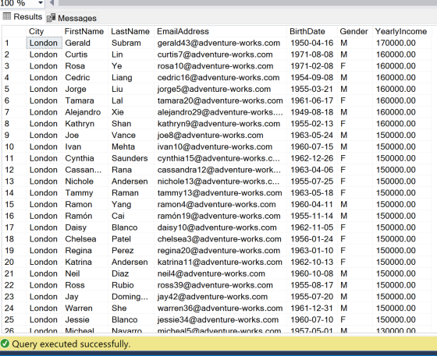

**Sample JSON Output (420 results returned):**

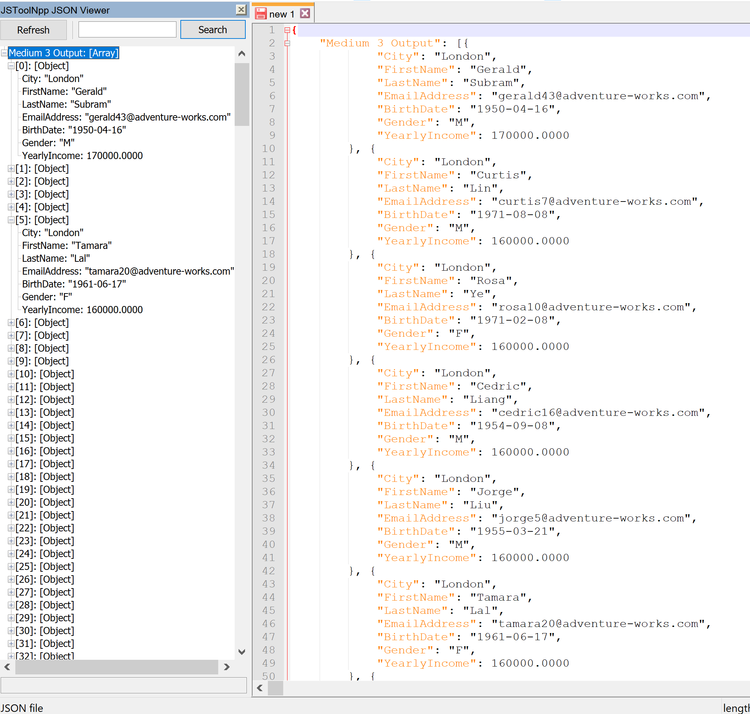

**MEDIUM 4:** This query finds the salaried employees who had the highest sales quotas to meet from 2010-2013

**Standard View:**

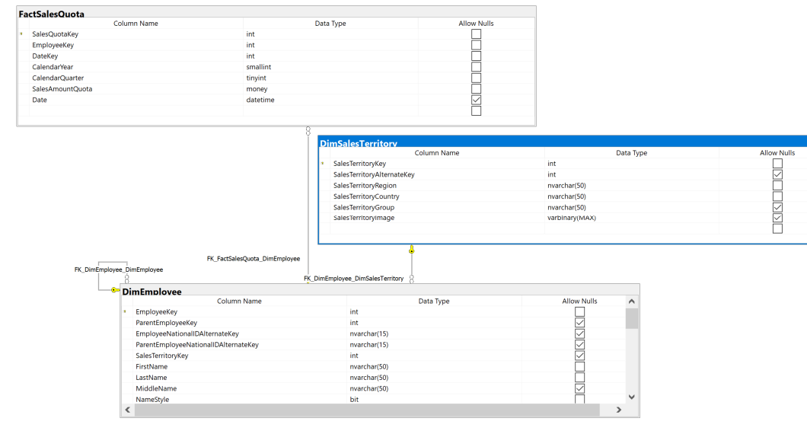

**Key View:**

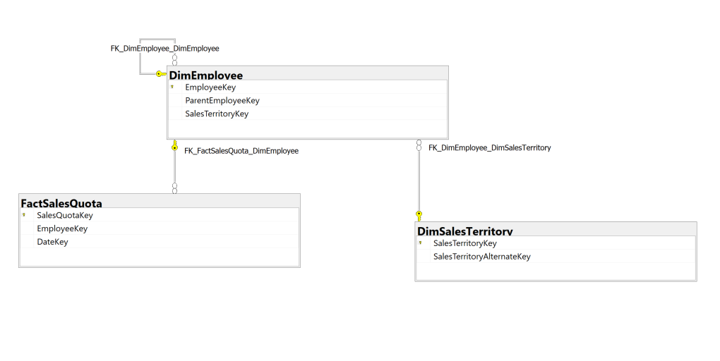

**Columns from tables:**

|  |  |
| --- | --- |
| **Table Name** | **Column Name** |
| Dbo.DimEmployee | Title  EmployeeKey  FirstName  LastName |
| Dbo.FactSalesQuota | CalendarYear  SalesAmountQuota |
| Dbo.DimSalesTerritory | SalesTerritoryRegion  SalesTerritoryCountry |

**Order By:**

|  |  |  |
| --- | --- | --- |
| **Table Name** | **Column Name** | **Sort Order** |
| Dbo.FactSalesQuota | SalesAmountQuota | DESC |

**Solution without JSON:**

USE AdventureWorksDW2017;

SELECT TOP 10 e.title

,e.employeekey

,e.firstName

,e.lastName

,q.calendarYear

,q.salesamountquota

,t.salesterritoryregion

,t.salesterritorycountry

FROM dbo.dimemployee AS e

INNER JOIN dbo.factsalesquota AS q ON e.employeekey = q.employeekey

INNER JOIN dbo.dimsalesterritory AS t ON e.salesterritorykey = t.salesterritorykey

WHERE e.salariedflag = 1

ORDER BY salesamountquota DESC

**Solution with JSON:**

USE AdventureWorksDW2017;

SELECT TOP 10 e.title

,e.employeekey

,e.firstName

,e.lastName

,q.calendarYear

,q.salesamountquota

,t.salesterritoryregion

,t.salesterritorycountry

FROM dbo.dimemployee AS e

INNER JOIN dbo.factsalesquota AS q ON e.employeekey = q.employeekey

INNER JOIN dbo.dimsalesterritory AS t ON e.salesterritorykey = t.salesterritorykey

WHERE e.salariedflag = 1

ORDER BY salesamountquota DESC

FOR JSON PATH, ROOT('Medium 4 Output'), INCLUDE_NULL_VALUES;

**Sample Output (10 results returned):**

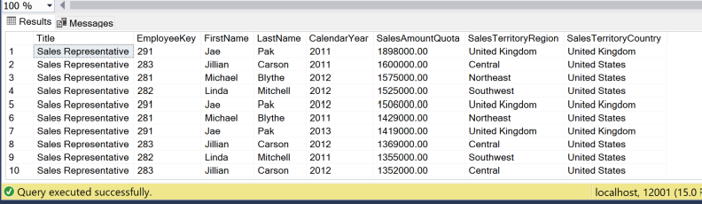

**Sample JSON Output (10 results returned):**

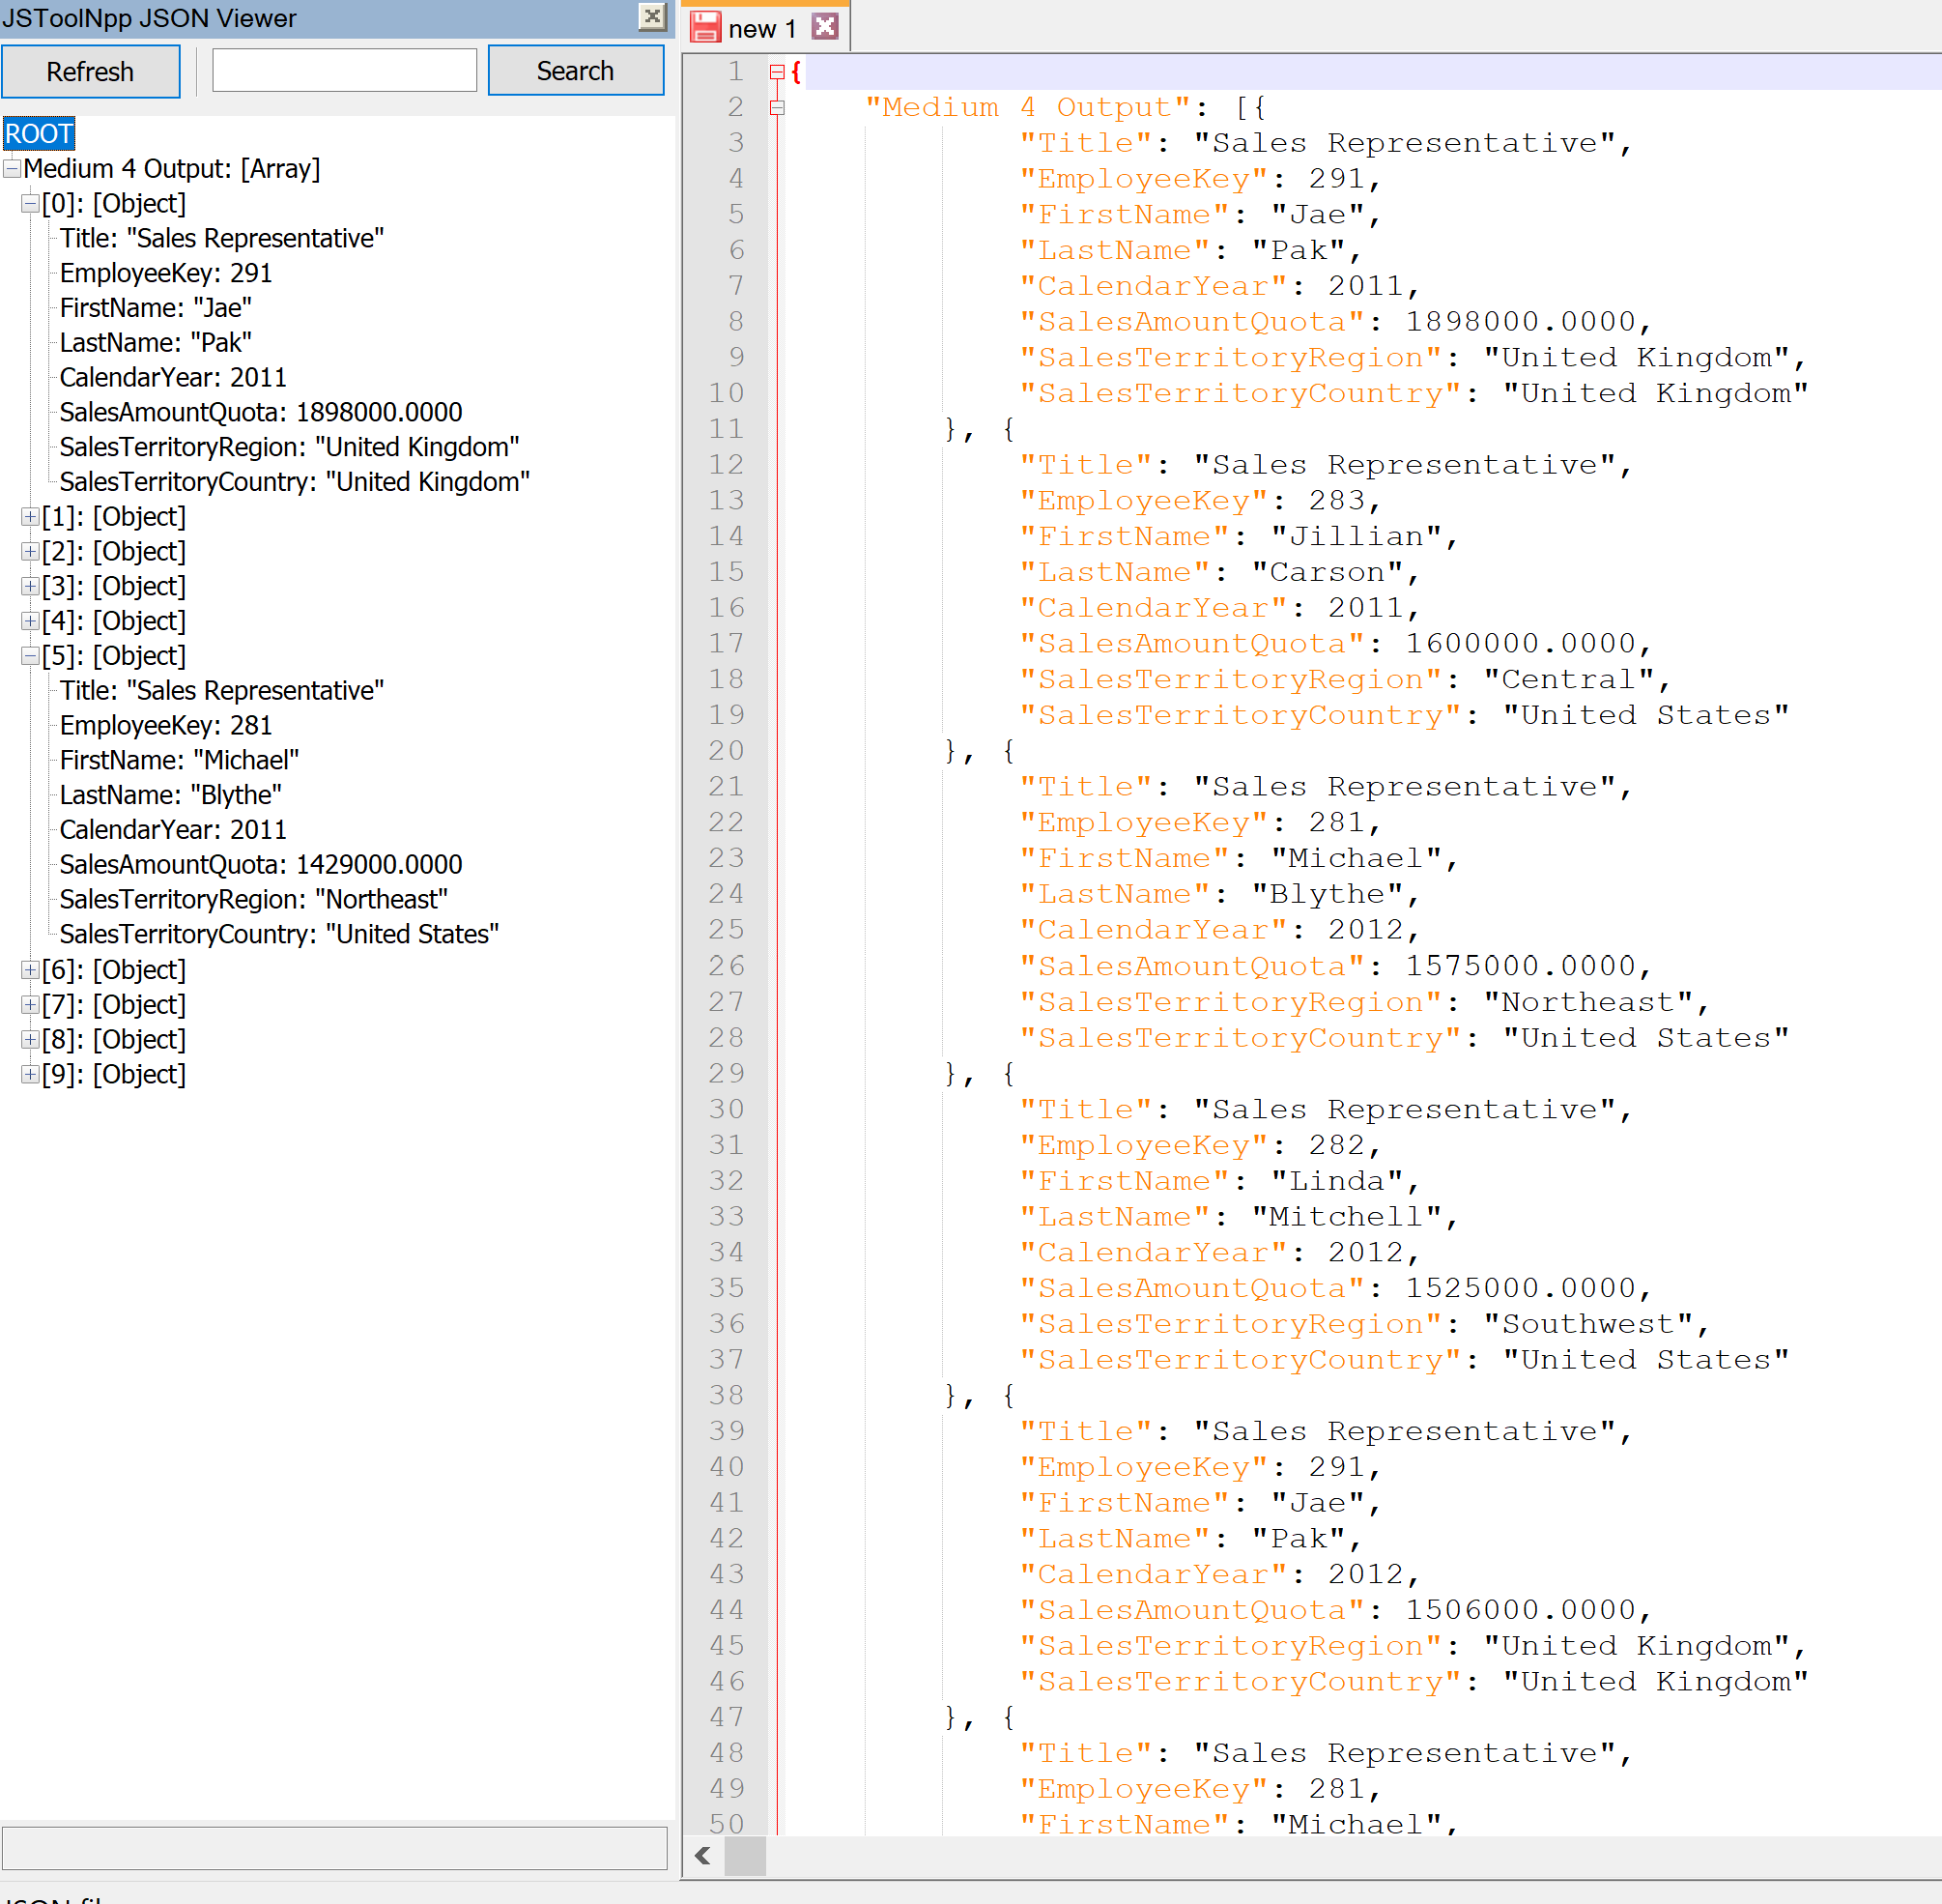

**MEDIUM 5:** This query finds the resellers who sold the most value and lists some information about each reseller

**Standard View:**

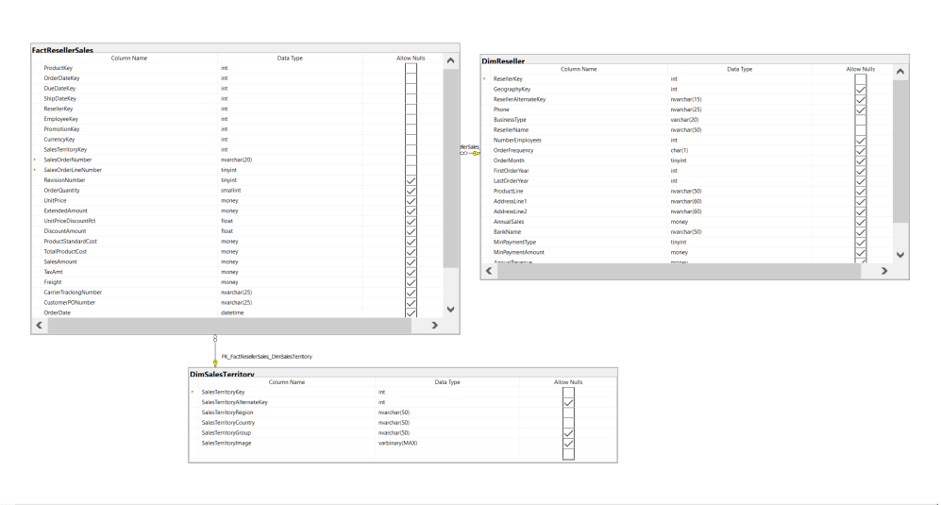

**Key View:**

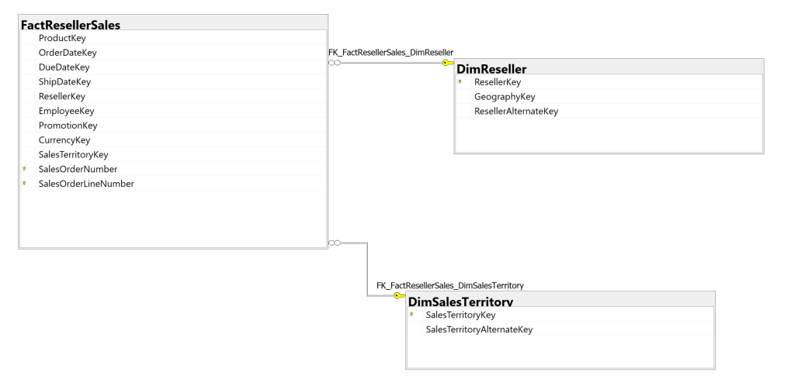

**Columns from tables:**

|  |  |
| --- | --- |
| **Table Name** | **Column Name** |
| Dbo.DimReseller | ResellerName  AnnualSales  NumberEmployees |
| Dbo.DimSalesTerritory | SalesTerritoryCountry  SalesTerritoryRegion |

**Order By:**

|  |  |  |
| --- | --- | --- |
| **Table Name** | **Column Name** | **Sort Order** |
| Dbo.DimReseller | AnnualSales | DESC |

**Solution without JSON:**

USE AdventureWorksDW2017;

SELECT sales.resellerkey

,rs.resellername

,rs.annualsales

,rs.numberemployees

,terr.salesterritorycountry

,terr.salesterritoryregion

FROM dbo.dimreseller AS rs

INNER JOIN dbo.factresellersales AS sales ON rs.resellerkey = sales.resellerkey

INNER JOIN dbo.dimsalesterritory AS terr ON sales.salesterritorykey = terr.salesterritorykey

WHERE rs.annualsales = (

SELECT max(annualsales)

FROM dbo.dimreseller

)

GROUP BY sales.resellerkey

,rs.resellername

,rs.annualsales

,rs.numberemployees

,terr.salesterritorycountry

,terr.salesterritoryregion

**Solution with JSON:**

USE AdventureWorksDW2017;

SELECT sales.resellerkey

,rs.resellername

,rs.annualsales

,rs.numberemployees

,terr.salesterritorycountry

,terr.salesterritoryregion

FROM dbo.dimreseller AS rs

INNER JOIN dbo.factresellersales AS sales ON rs.resellerkey = sales.resellerkey

INNER JOIN dbo.dimsalesterritory AS terr ON sales.salesterritorykey = terr.salesterritorykey

WHERE rs.annualsales = (

SELECT max(annualsales)

FROM dbo.dimreseller

)

GROUP BY sales.resellerkey

,rs.resellername

,rs.annualsales

,rs.numberemployees

,terr.salesterritorycountry

,terr.salesterritoryregion

FOR JSON PATH, ROOT('Medium 5 Output'), INCLUDE_NULL_VALUES;

**Sample Output (193 results returned):**

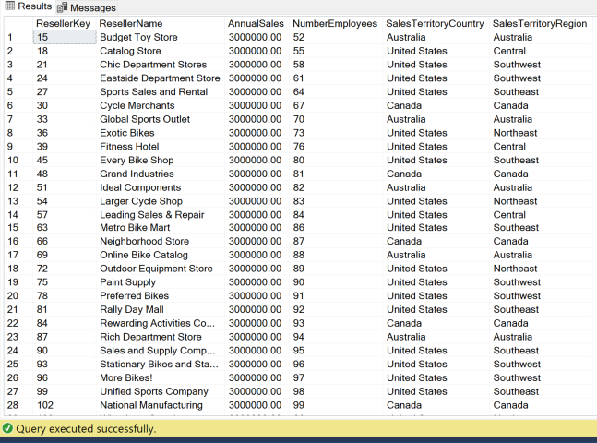

**Sample JSON Output:**

**MEDIUM 6:** This query List the most popular items from internet sales and give some details

**Standard View:**

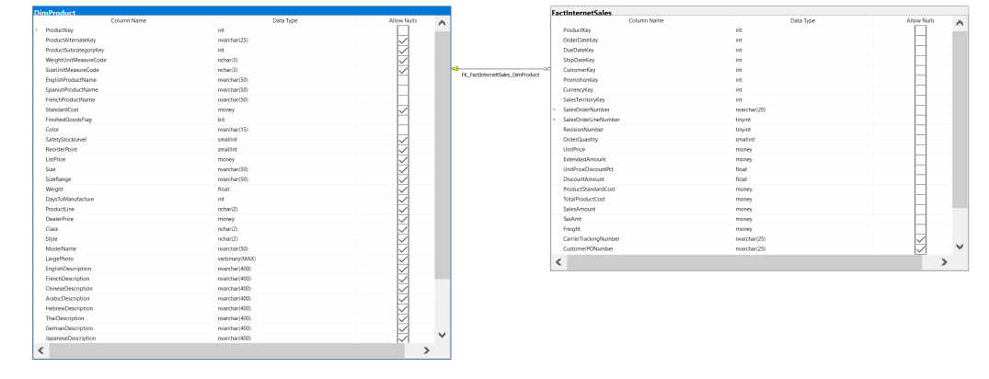

**Key View:**

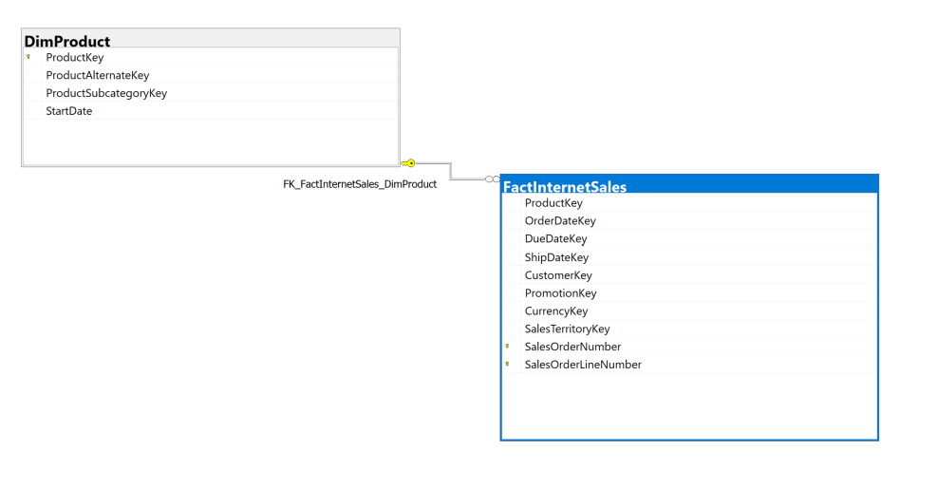

**Columns from tables:**

|  |  |
| --- | --- |
| **Table Name** | **Column Name** |
| Dbo.FactInternetSales | ProductKey  UnitPrice |
| Dbo.DimProduct | EnglishProductName |

|  |  |  |
| --- | --- | --- |
| **Table Name** | **Column Name** | **Sort Order** |
| Dbo.FactInternetSales | NumSales | Desc |

**Order By:**

**Solution without JSON:**

USE AdventureWorksDW2017;

SELECT sales.productkey

,prod.englishproductname

,sales.unitprice

,count(*) AS NumSales

,sales.unitprice * count(*) AS ValueSold

FROM dbo.factinternetsales AS sales

INNER JOIN dbo.dimproduct AS prod ON sales.productkey = prod.productkey

GROUP BY sales.productkey

,prod.englishproductname

,sales.unitprice

ORDER BY count(*) DESC

**Solution with JSON:**

USE AdventureWorksDW2017;

SELECT sales.productkey

,prod.englishproductname

,sales.unitprice

,count(*) AS NumSales

,sales.unitprice * count(*) AS ValueSold

FROM dbo.factinternetsales AS sales

INNER JOIN dbo.dimproduct AS prod ON sales.productkey = prod.productkey

GROUP BY sales.productkey

,prod.englishproductname

,sales.unitprice

ORDER BY count(*) DESC

FOR JSON PATH, ROOT('Medium 6 Output'), INCLUDE_NULL_VALUES;

**Sample Output (158 results returned):**

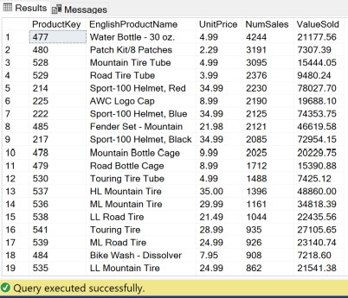

**Sample JSON Output (158 results returned):**

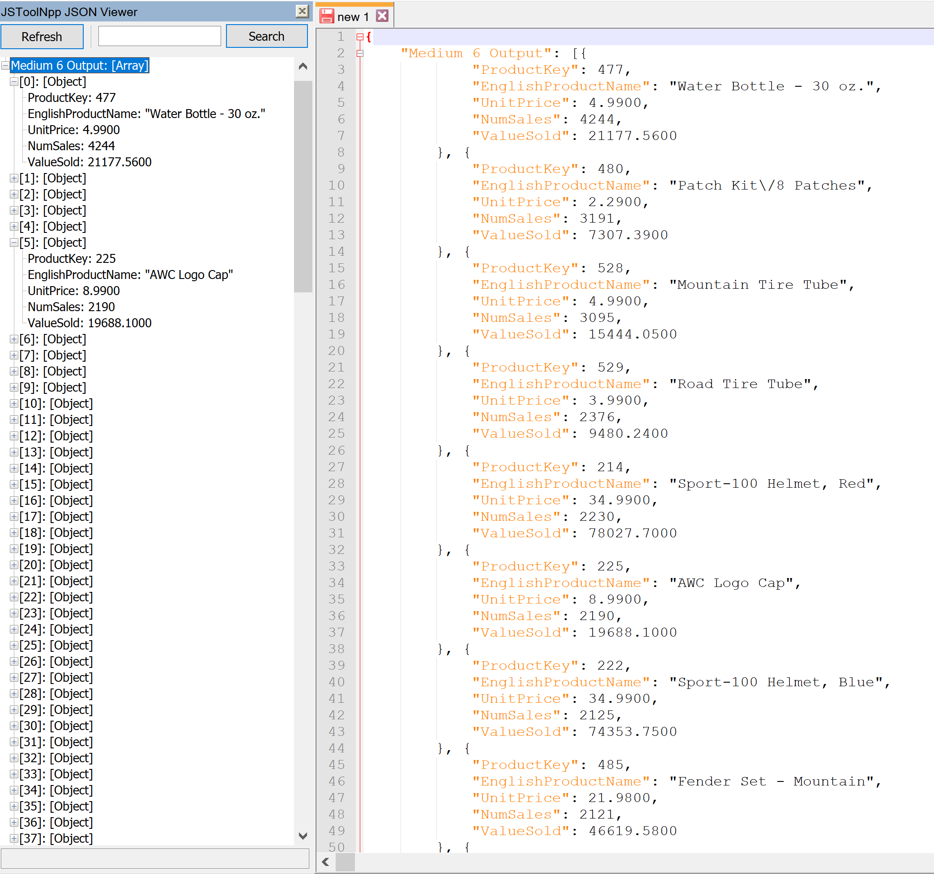

**MEDIUM 7:** This query orders departments based on the number of employees, possibly if layoffs are needed

**Standard View:**

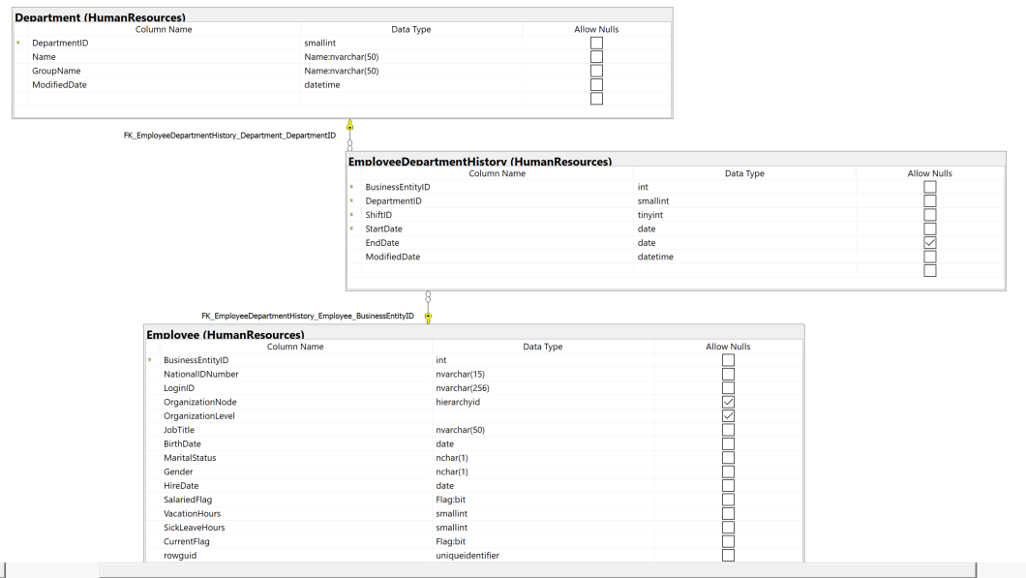

**Key View:**

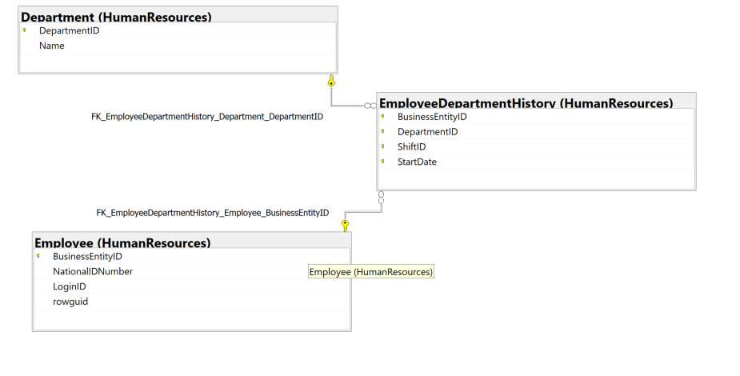

**Columns from tables:**

|  |  |
| --- | --- |
| **Table Name** | **Column Name** |
| HumanResources.EmployeeDepartementHistory | DepartementId  Name |
| HumanResources.Employee | NumEmployees |

**Order By:**

|  |  |  |
| --- | --- | --- |
| **Table Name** | **Column Name** | **Sort Order** |
| HumanResources.Employee | NumEmployees | DESC |

**Solution without JSON:**

USE AdventureWorks2017;

SELECT depohist.departmentid

,depo.name AS DepartmentName

,count(e.BusinessEntityID) AS NumEmployees

FROM HumanResources.employee AS E

INNER JOIN HumanResources.employeedepartmenthistory AS depohist ON e.BusinessEntityID = depohist.BusinessEntityID

INNER JOIN humanresources.department AS depo ON depohist.departmentid = depo.departmentid

GROUP BY depohist.departmentid

,depo.name

ORDER BY count(e.BusinessEntityID) DESC

**Solution with JSON:**

USE AdventureWorks2017;

SELECT depohist.departmentid

,depo.name AS DepartmentName

,count(e.BusinessEntityID) AS NumEmployees

FROM HumanResources.employee AS E

INNER JOIN HumanResources.employeedepartmenthistory AS depohist ON e.BusinessEntityID = depohist.BusinessEntityID

INNER JOIN humanresources.department AS depo ON depohist.departmentid = depo.departmentid

GROUP BY depohist.departmentid

,depo.name

ORDER BY count(e.BusinessEntityID) DESC

FOR JSON PATH, ROOT('Medium 7 Output'), INCLUDE_NULL_VALUES;

**Sample Output (16 results returned):**

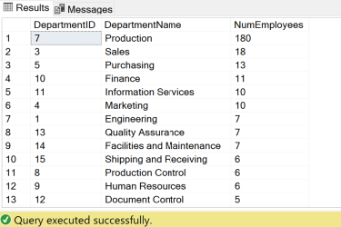

**Sample JSON Output (16 results returned):**

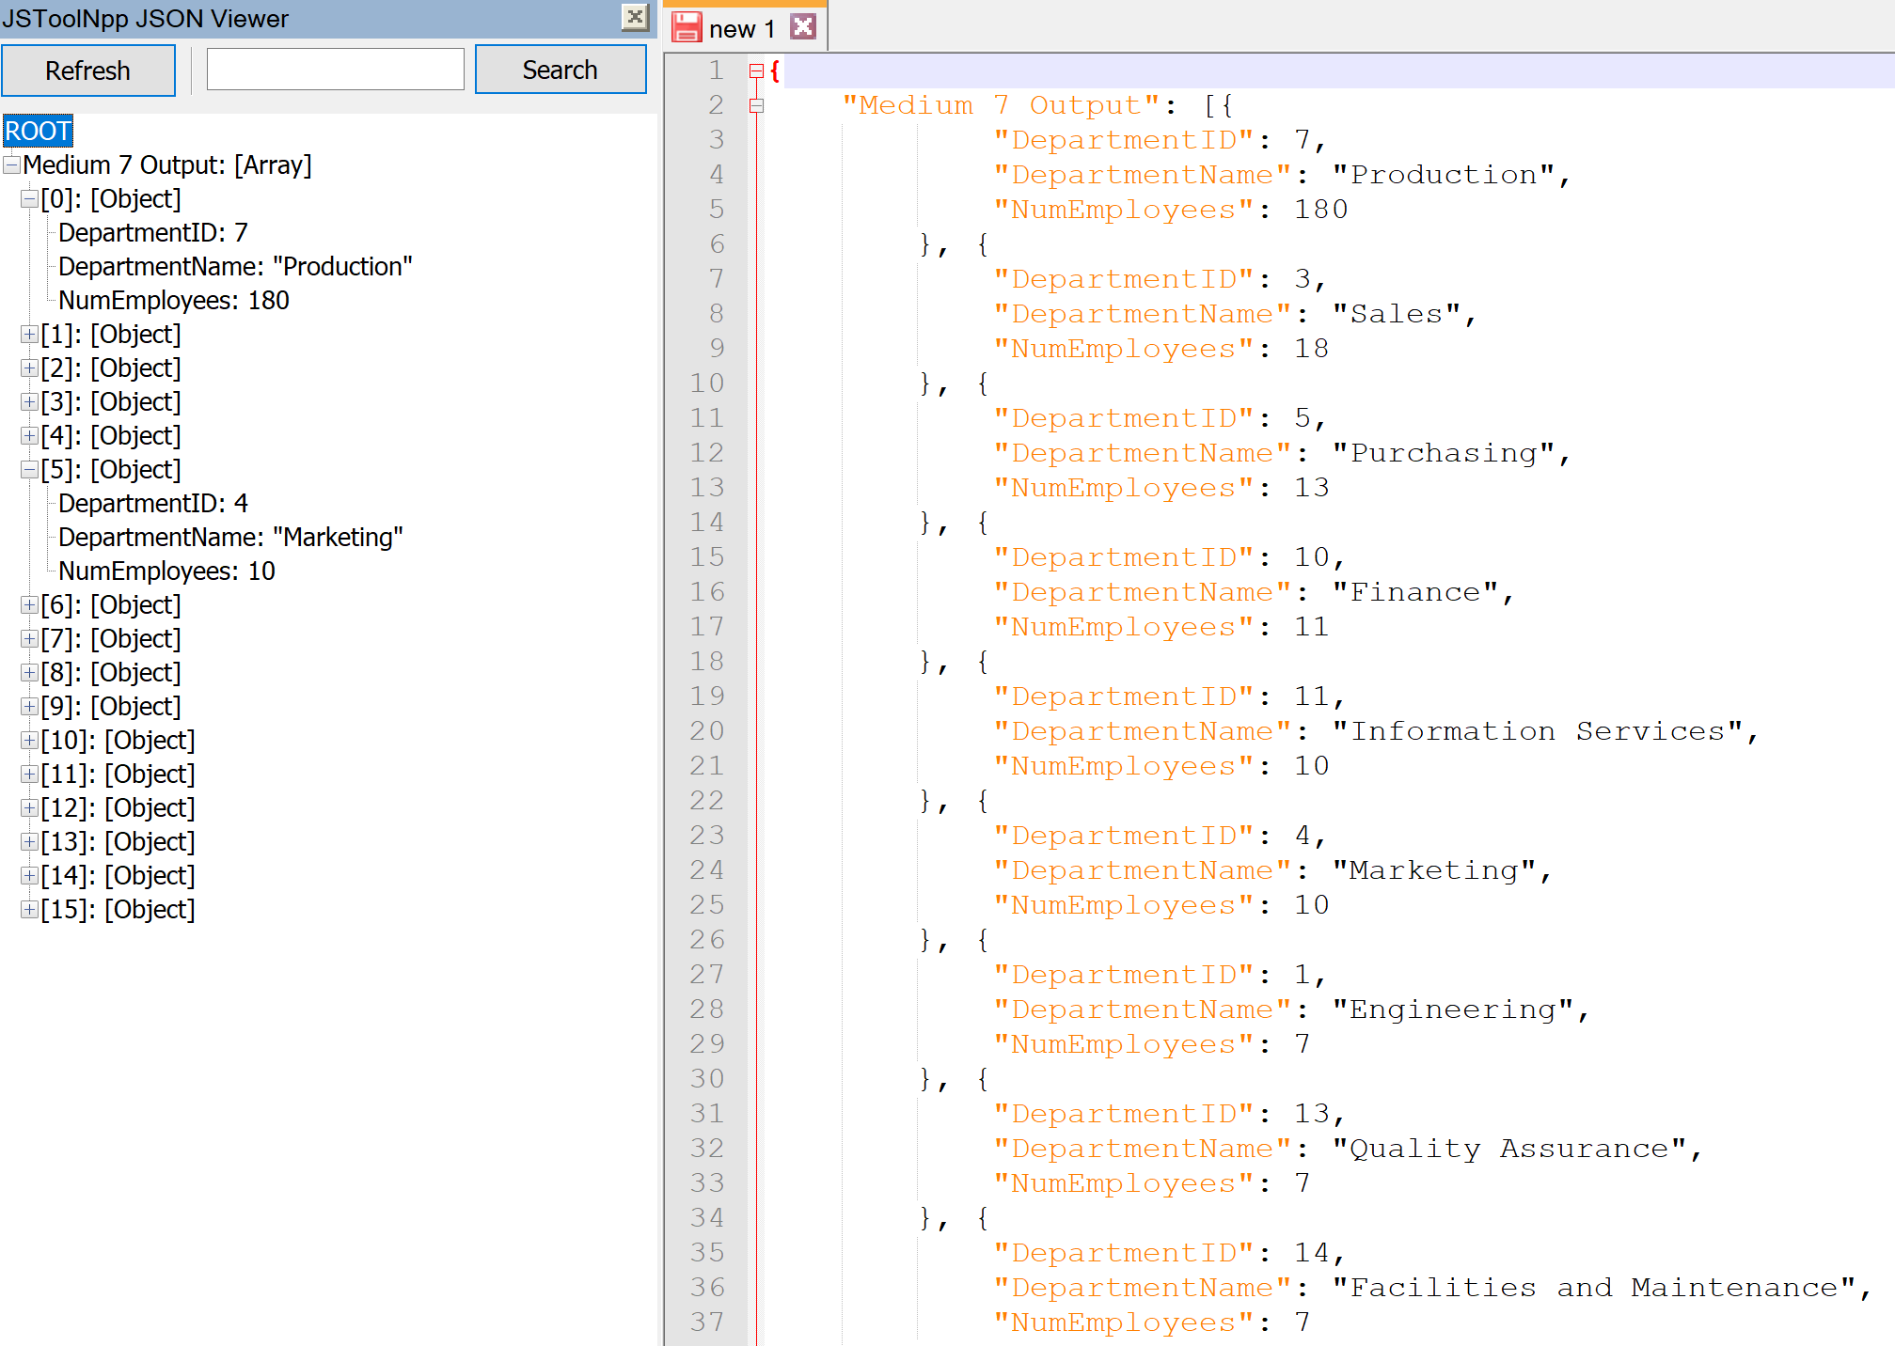

**MEDIUM 8:** This query lists the most profitable products

**Standard View:**

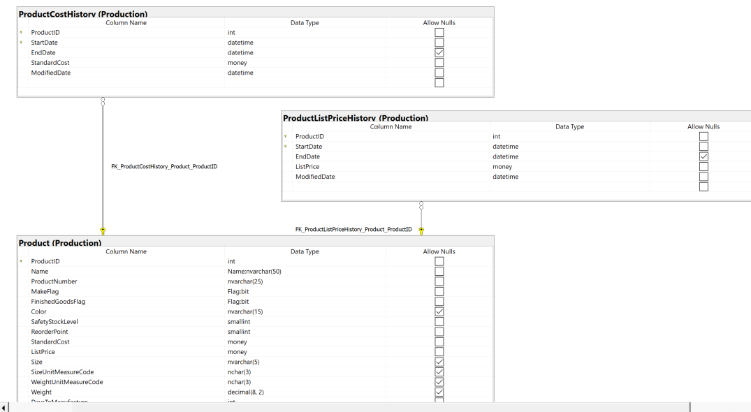

**Key View:**

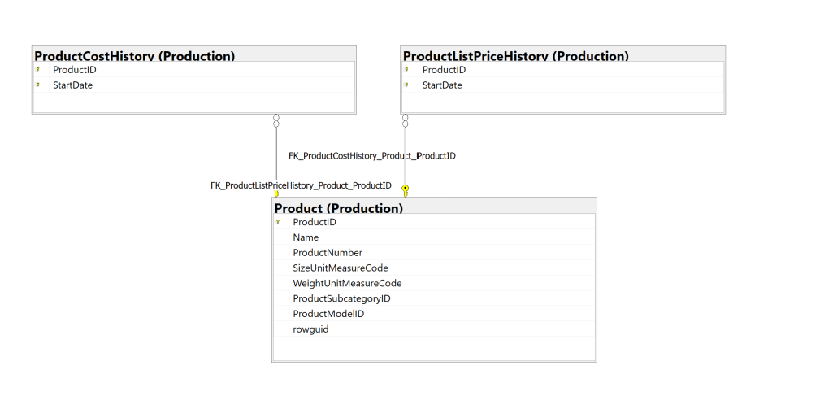

**Columns from tables:**

|  |  |
| --- | --- |
| **Table Name** | **Column Name** |
| Production.Product | ProductId  Name |
| Production.ProductCostHistory | AvgCostToProd |
| Production.ListPriceHistory | AvgSellPrice |

**Order By:**

|  |  |  |
| --- | --- | --- |
| **Table Name** | **Column Name** | **Sort Order** |
| Production.ProductListHistory | AvgProfit | DESC |

**Solution without JSON:**

USE AdventureWorks2017;

SELECT prod.productid

,prod.name AS ProductName

,avg(cost.standardcost) AS AvgCostToProd

,avg(list.listprice) AS AvgSellPrice

,avg(list.listprice) - avg(cost.standardcost) AS AvgProfit

FROM production.product AS prod

INNER JOIN production.productcosthistory AS cost ON prod.ProductId = cost.ProductId

INNER JOIN production.productlistpricehistory AS list ON prod.productid = list.ProductId

GROUP BY prod.productid

,prod.name

ORDER BY AvgProfit DESC

**Solution with JSON:**

USE AdventureWorks2017;

SELECT prod.productid

,prod.name AS ProductName

,avg(cost.standardcost) AS AvgCostToProd

,avg(list.listprice) AS AvgSellPrice

,avg(list.listprice) - avg(cost.standardcost) AS AvgProfit

FROM production.product AS prod

INNER JOIN production.productcosthistory AS cost ON prod.ProductId = cost.ProductId

INNER JOIN production.productlistpricehistory AS list ON prod.productid = list.ProductId

GROUP BY prod.productid

,prod.name

ORDER BY AvgProfit DESC

FOR JSON PATH, ROOT('Medium 8 Output'), INCLUDE_NULL_VALUES;

**Sample Output (293 results returned):**

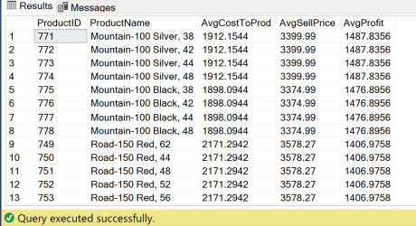

**Sample JSON Output (293 results returned):**

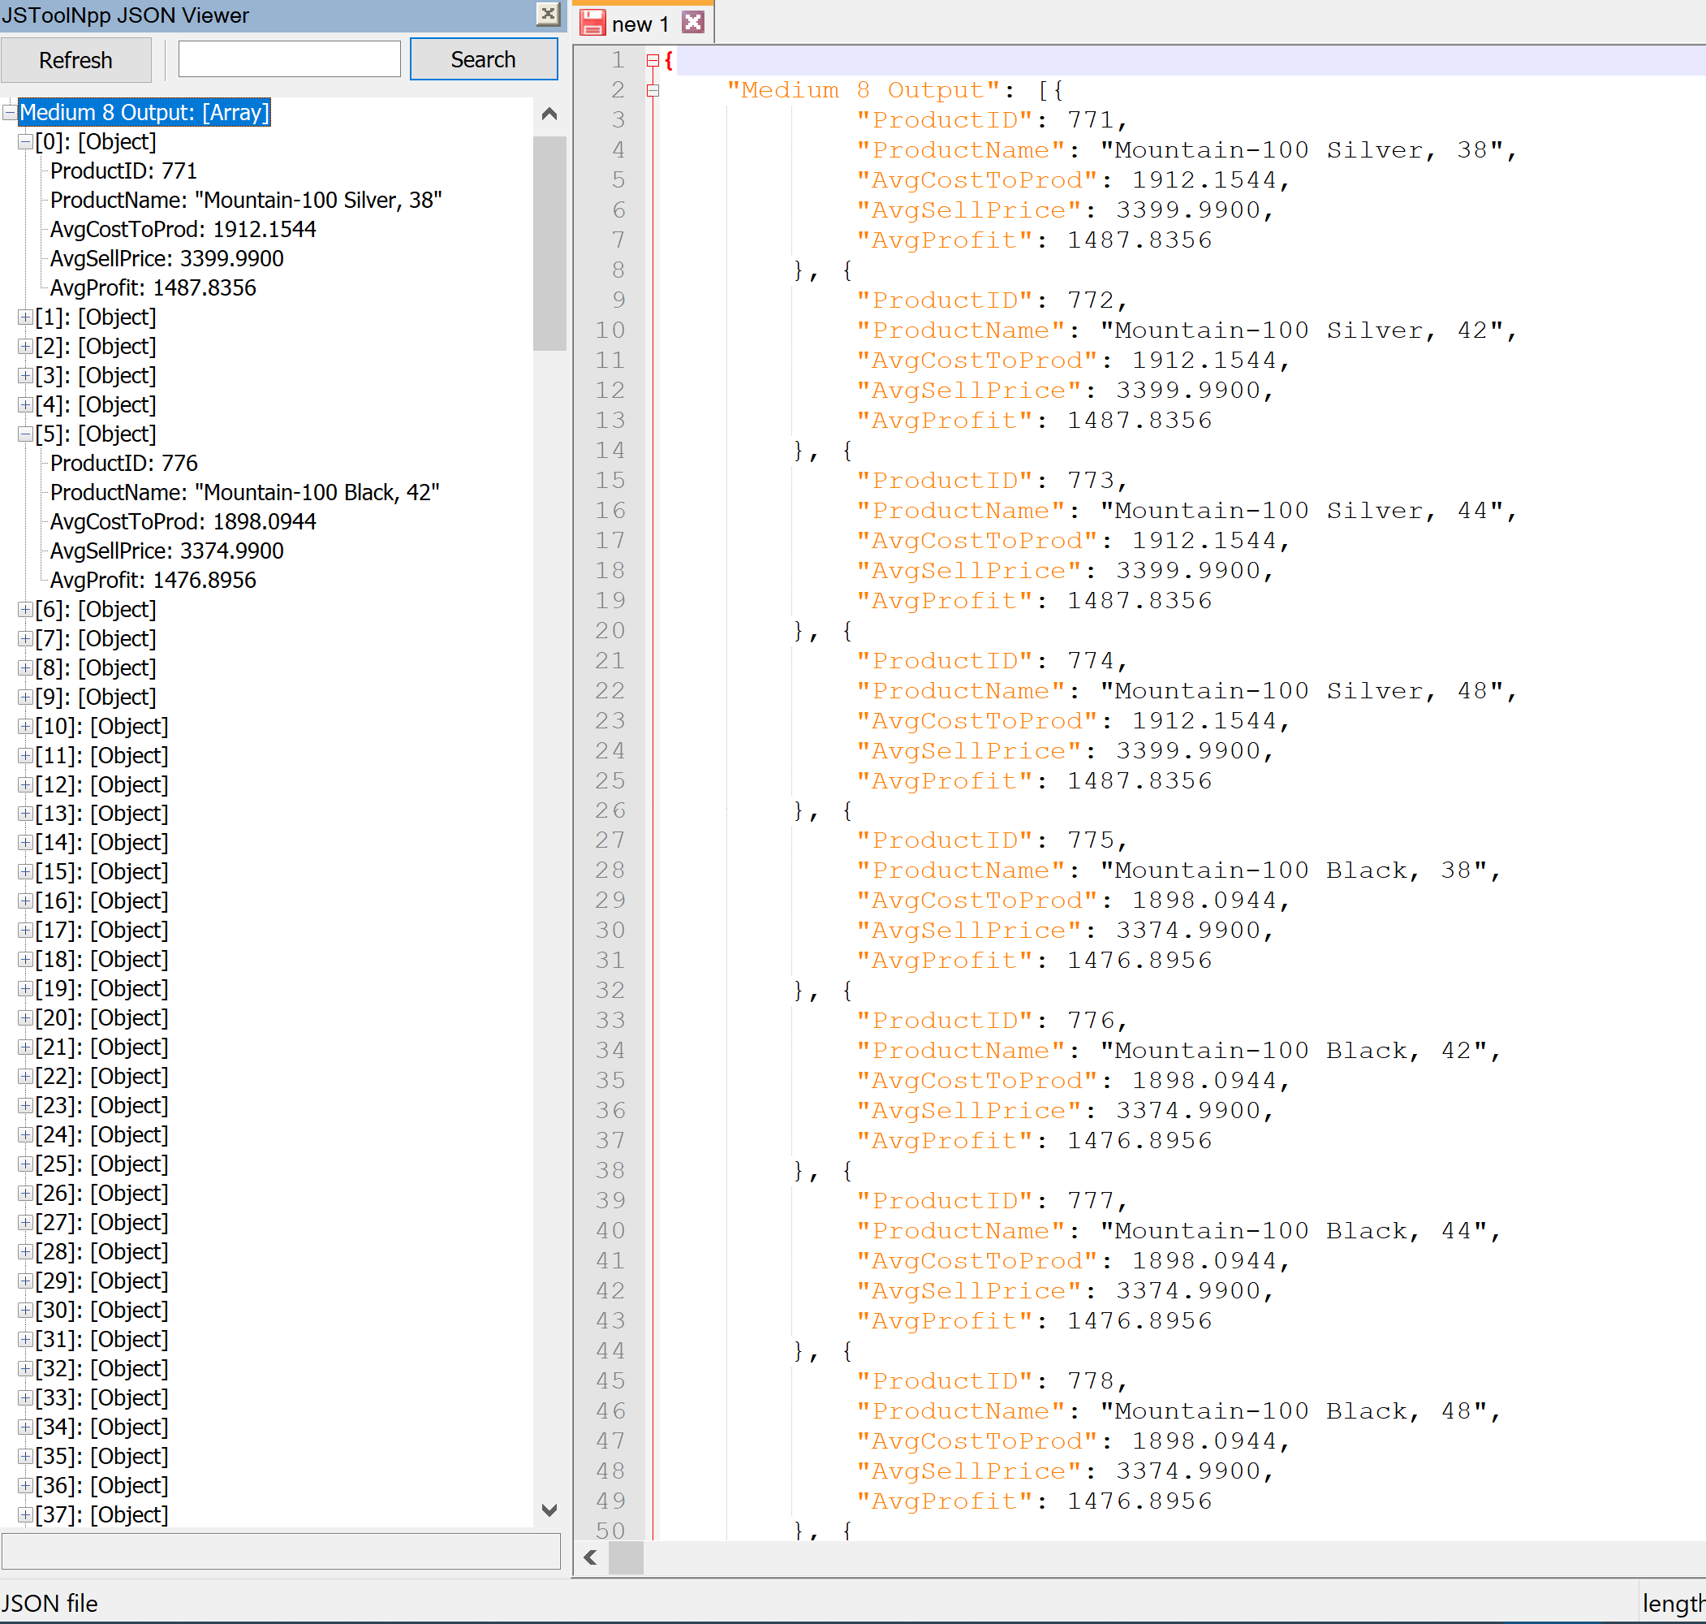

**COMPLEX 1:**

QUERY: This query finds the average amount of days it takes to process a customer’s order, from placing the order to shipping it out. Additional information about the customer is returned to determine whether there may be any correlations in disparities. This query also finds the employee who services that customer the most.

FUNCTIONS: [calcDateAvg] calculates the average amount of days from the order being placed to it being shipped out across all orders for the specified customer. [favEmployee] returns the name of the employee that services the specified customer

**Standard View:**

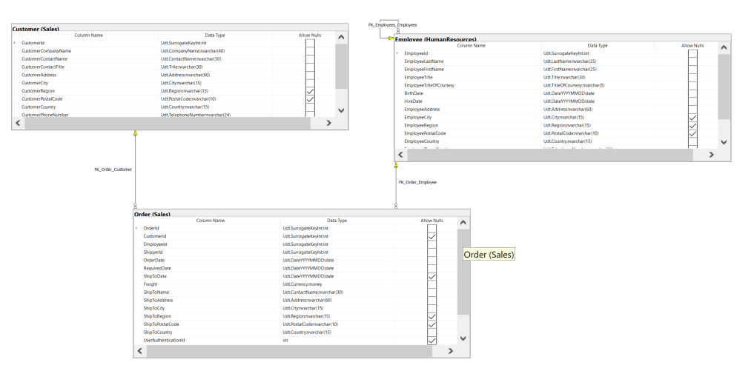

**Key View:**

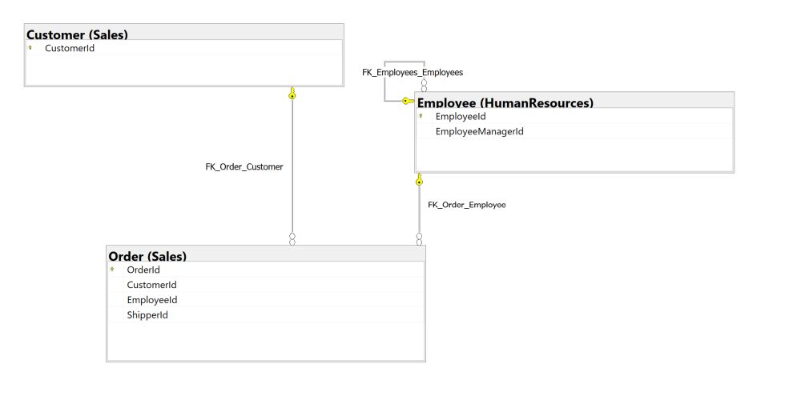

**Columns from tables:**

|  |  |
| --- | --- |
| **Table Name** | **Column Name** |
| Sales.Customer | CustomerId  CustomerContactName  CustomerCity |
| Sales.Order | AvgResponseInDays |
| HumanResources.Employee | FreqHandledBy |

**Order By:**

|  |  |  |
| --- | --- | --- |
| **Table Name** | **Column Name** | **Sort Order** |
| Sales.Order | AvgResponseInDays | ASC |

**Solution without JSON:**

USE Northwinds2020TSQLV6;

GO

CREATE FUNCTION [sales].[calcDateAvg] (@id INT)

RETURNS INT

AS

BEGIN

DECLARE @avg INT;

SET @avg = (

SELECT avg(DATEDIFF(day, orderdate, shiptodate))

FROM sales.[order]

WHERE customerid = @id

GROUP BY customerid

)

RETURN @avg

END

GO

DROP FUNCTION

IF EXISTS [sales].[calcDateAvg]

---------------------------------

GO

CREATE FUNCTION [sales].[favEmployee] (@custId INT)

RETURNS NVARCHAR(100)

AS

BEGIN

DECLARE @favEmp NVARCHAR(100);

DECLARE @empl INT;

SET @empl = (

SELECT TOP 1 EmployeeId

FROM sales.[order]

WHERE CustomerId = @custId

GROUP BY CustomerId

,EmployeeId

ORDER BY count(EmployeeId) DESC

)

SET @favEmp = (

SELECT EmployeeFirstName

FROM HumanResources.Employee

WHERE EmployeeId = @empl

) + ' ' + (

SELECT EmployeeLastName

FROM HumanResources.Employee

WHERE EmployeeId = @empl

)

RETURN @favEmp

END

GO

DROP FUNCTION

IF EXISTS [sales].[favEmployee]

USE Northwinds2020TSQLV6;

SELECT c.customerid

,c.CustomerContactName

,c.CustomerCity

,[sales].[calcDateAvg](c.customerid) AS AvgResponseInDays

,count(so.customerid) AS NumOrders

,[Sales].[favemployee](c.CustomerId) AS FreqHandBy

FROM sales.[order] AS so

INNER JOIN sales.customer AS c ON so.customerid = c.customerid

INNER JOIN HumanResources.Employee AS e ON so.EmployeeId = e.EmployeeId

GROUP BY c.customerid

,c.CustomerContactName

,c.CustomerCity

ORDER BY AvgResponseInDays ASC

**Solution with JSON:**

USE Northwinds2020TSQLV6;

GO

CREATE FUNCTION [sales].[calcDateAvg] (@id INT)

RETURNS INT

AS

BEGIN

DECLARE @avg INT;

SET @avg = (

SELECT avg(DATEDIFF(day, orderdate, shiptodate))

FROM sales.[order]

WHERE customerid = @id

GROUP BY customerid

)

RETURN @avg

END

GO

DROP FUNCTION

IF EXISTS [sales].[calcDateAvg]

---------------------------------

GO

CREATE FUNCTION [sales].[favEmployee] (@custId INT)

RETURNS NVARCHAR(100)

AS

BEGIN

DECLARE @favEmp NVARCHAR(100);

DECLARE @empl INT;

SET @empl = (

SELECT TOP 1 EmployeeId

FROM sales.[order]

WHERE CustomerId = @custId

GROUP BY CustomerId

,EmployeeId

ORDER BY count(EmployeeId) DESC

)

SET @favEmp = (

SELECT EmployeeFirstName

FROM HumanResources.Employee

WHERE EmployeeId = @empl

) + ' ' + (

SELECT EmployeeLastName

FROM HumanResources.Employee

WHERE EmployeeId = @empl

)

RETURN @favEmp

END

GO

DROP FUNCTION

IF EXISTS [sales].[favEmployee]

USE Northwinds2020TSQLV6;

SELECT c.customerid

,c.CustomerContactName

,c.CustomerCity

,[sales].[calcDateAvg](c.customerid) AS AvgResponseInDays

,count(so.customerid) AS NumOrders

,[Sales].[favemployee](c.CustomerId) AS FreqHandBy

FROM sales.[order] AS so

INNER JOIN sales.customer AS c ON so.customerid = c.customerid

INNER JOIN HumanResources.Employee AS e ON so.EmployeeId = e.EmployeeId

GROUP BY c.customerid

,c.CustomerContactName

,c.CustomerCity

ORDER BY AvgResponseInDays ASC

FOR JSON PATH, ROOT('Complex 1 Output'), INCLUDE_NULL_VALUES;

**Sample Output (89 results returned):**

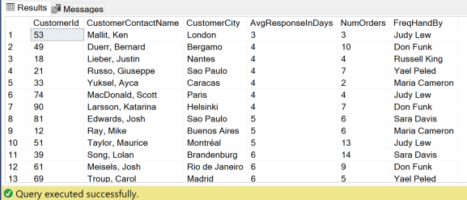

**Sample JSON Output (89 results returned):**

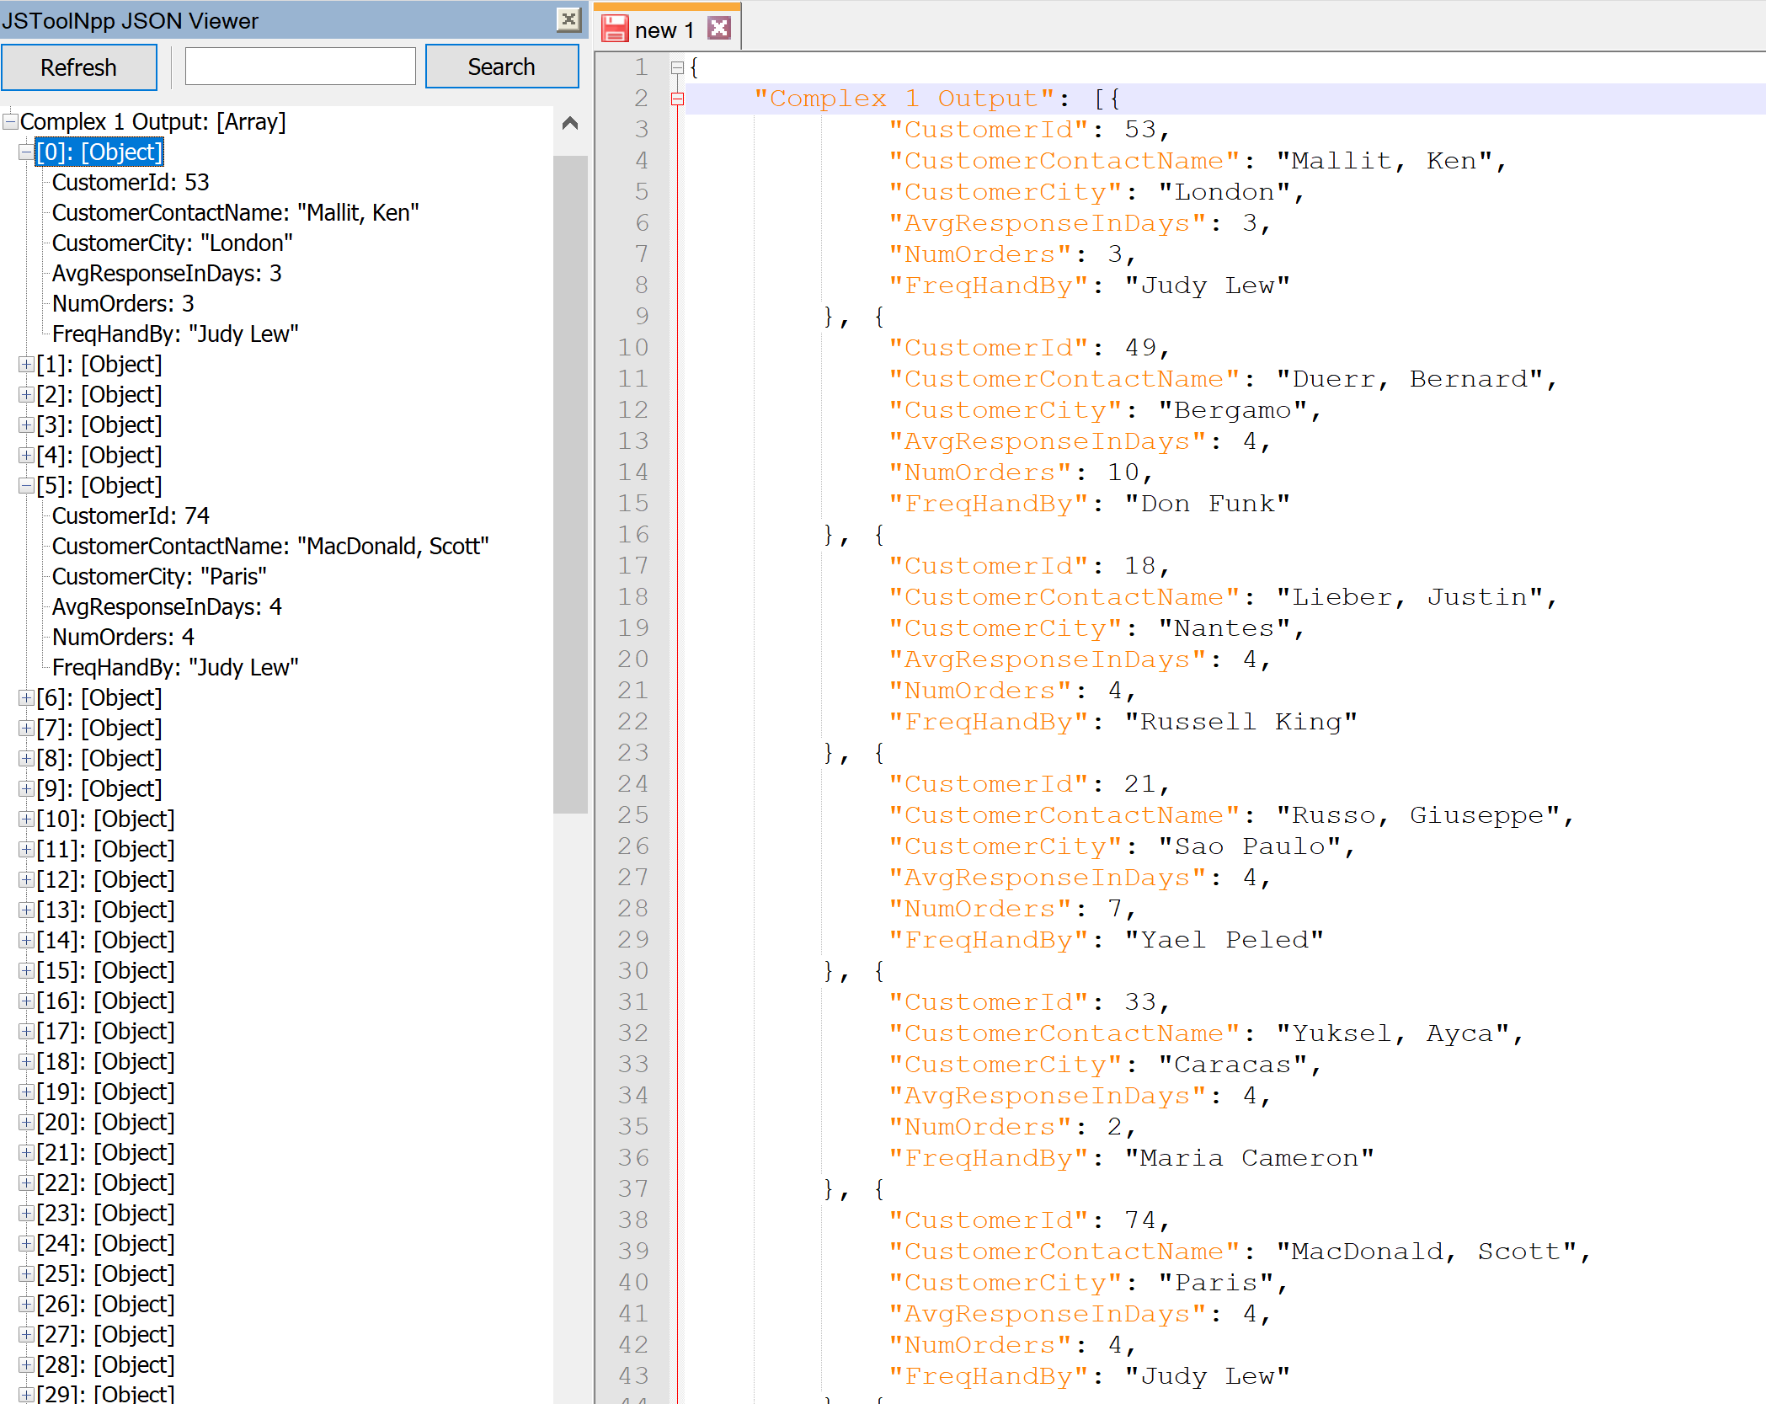

**COMPLEX 2:**

QUERY: This query ranks all shippers based on the number of deliveries their company have completed. This query also list the customer that each shipper delivers most frequently to.

FUNCTIONS: [freqCust] finds the customer that the specified shipper has delivered to most.

**Standard View:**

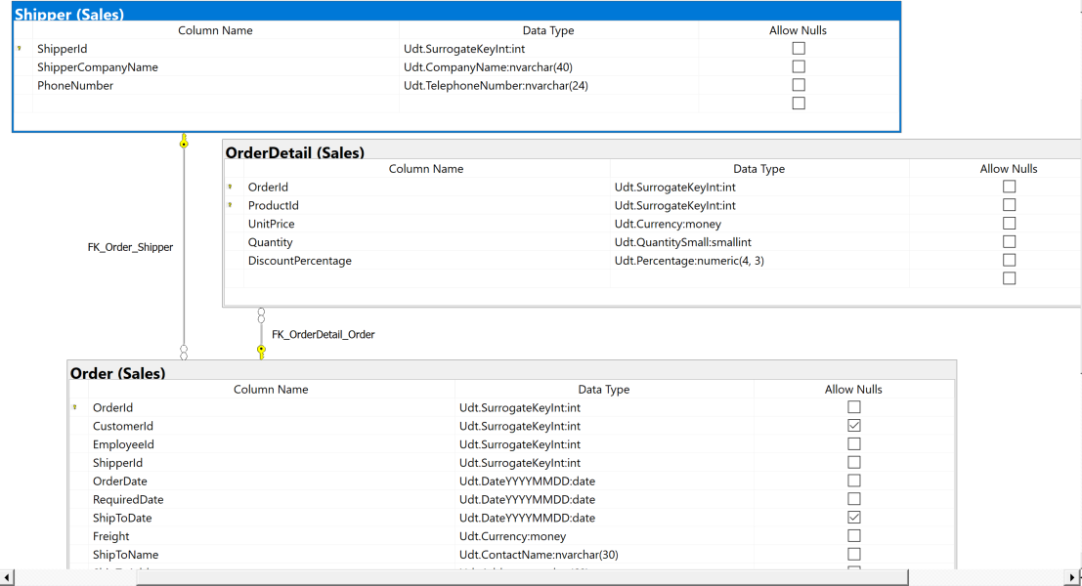

**Key View:**

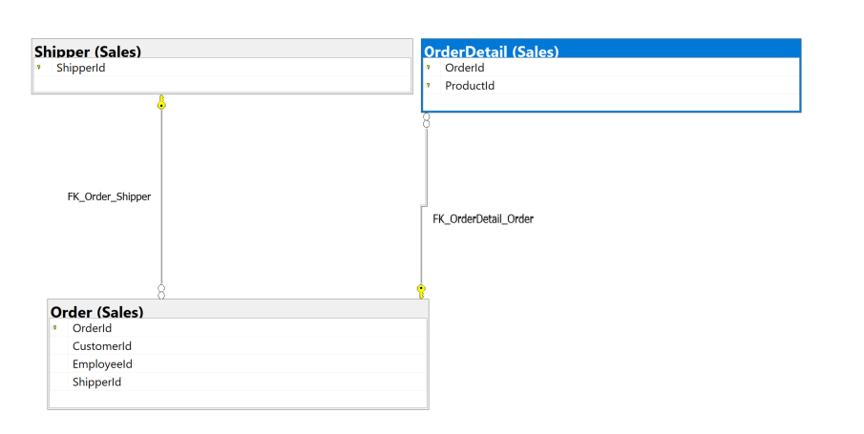

**Columns from tables:**

|  |  |
| --- | --- |
| **Table Name** | **Column Name** |
| Sales.Shipper | ShipperId  ShipperCompanyName  NumDeliveries  FreqCust |

**Order By:**

|  |  |  |
| --- | --- | --- |
| **Table Name** | **Column Name** | **Sort Order** |
| Sales.Shipper | NumDeliveries | DESC |

**Solution without JSON:**

USE Northwinds2020TSQLV6;

GO

CREATE FUNCTION sales.[freqCust] (@supid INT)

RETURNS NVARCHAR(100)

AS

BEGIN

DECLARE @custid INT;

DECLARE @custName NVARCHAR(100);

SET @custid = (

SELECT TOP 1 CustomerId

FROM Sales.[Order]

WHERE ShipperId = @supid

GROUP BY ShipperId

,CustomerId

ORDER BY COUNT(CustomerId) DESC

);

SET @custName = (

SELECT CustomerContactName

FROM Sales.Customer

WHERE CustomerId = @custid

)

RETURN @custname

END

GO

SELECT s.ShipperId

,s.ShipperCompanyName

,count(o.ShipperId) AS NumDeliveries

,sales.[freqCust](s.ShipperId) AS FreqCust

FROM Sales.[Order] AS o

INNER JOIN Sales.OrderDetail AS od ON o.OrderId = od.OrderId

INNER JOIN sales.Shipper AS s ON s.shipperid = o.ShipperId

GROUP BY s.ShipperId

,s.ShipperCompanyName

ORDER BY NumDeliveries DESC

**Solution with JSON:**

USE Northwinds2020TSQLV6;

GO

CREATE FUNCTION sales.[freqCust] (@supid INT)

RETURNS NVARCHAR(100)

AS

BEGIN

DECLARE @custid INT;

DECLARE @custName NVARCHAR(100);

SET @custid = (

SELECT TOP 1 CustomerId

FROM Sales.[Order]

WHERE ShipperId = @supid

GROUP BY ShipperId

,CustomerId

ORDER BY COUNT(CustomerId) DESC

);

SET @custName = (

SELECT CustomerContactName

FROM Sales.Customer

WHERE CustomerId = @custid

)

RETURN @custname

END

GO

USE Northwinds2020TSQLV6;

SELECT s.ShipperId

,s.ShipperCompanyName

,count(o.ShipperId) AS NumDeliveries

,sales.[freqCust](s.ShipperId) AS FreqCust

FROM Sales.[Order] AS o

INNER JOIN Sales.OrderDetail AS od ON o.OrderId = od.OrderId

INNER JOIN sales.Shipper AS s ON s.shipperid = o.ShipperId

GROUP BY s.ShipperId

,s.ShipperCompanyName

ORDER BY NumDeliveries DESC

FOR JSON PATH, ROOT('Complex 2 Output'), INCLUDE_NULL_VALUES;

**Sample Output (3 results returned):**

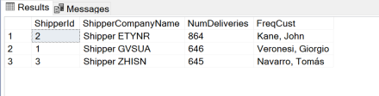

**Sample JSON Output (3 results returned):**

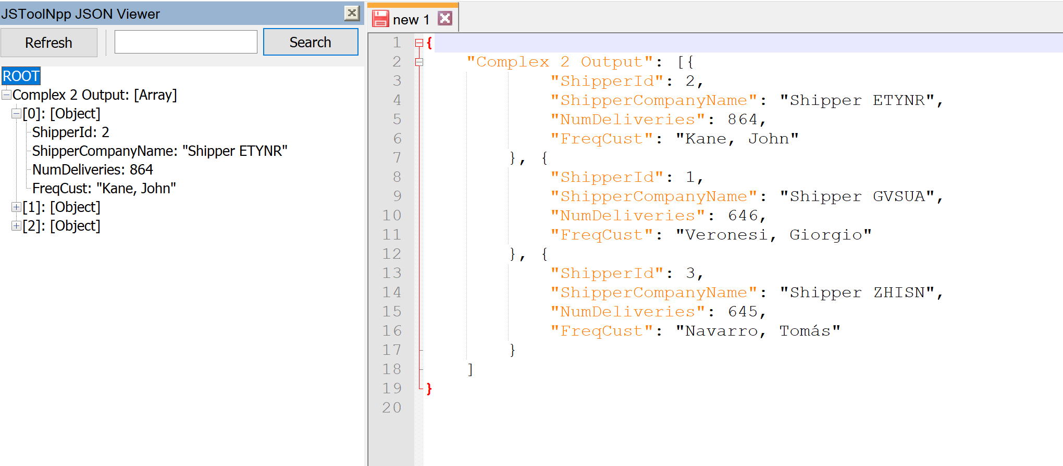

**COMPLEX 3:**

QUERY: This query ranks store’s catalogs based on the average cost of all their goods. This query also finds each store’s most expensive item along with some information about that product.

FUNCTIONS: [avgIntValue] finds the average price of all the specified supplier’s goods. [mostExpProd] finds the most expensive item of the specified supplier.

**Standard View:**

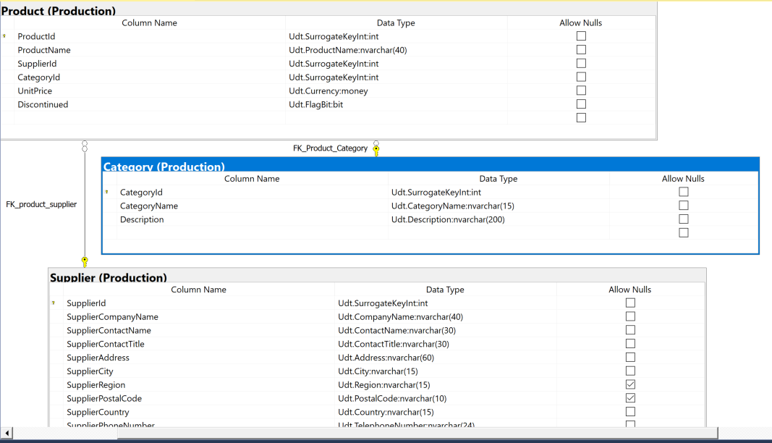

**Key View:**

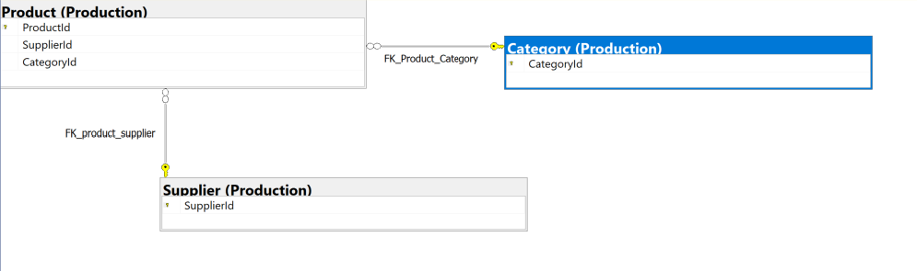

**Columns from tables:**

|  |  |
| --- | --- |
| **Table Name** | **Column Name** |
| Production.Supplier | SupplierId  SupplierCompanyName |
| Production.Product | MostValProdPrice  ProdName |
| Production.Category | Category  Description  AvgCatelogValue |

**Order By:**

|  |  |  |
| --- | --- | --- |
| **Table Name** | **Column Name** | **Sort Order** |
| Production.Supplier | AvgCatelogValue | DESC |

**Solution without JSON:**

USE Northwinds2020TSQLV6;

GO

CREATE FUNCTION Production.[avgInvtValue] (@supid INT)

RETURNS FLOAT

AS

BEGIN

DECLARE @avg FLOAT;

SET @avg = (

SELECT avg(UnitPrice)

FROM Production.Product

WHERE SupplierId = @supid

)

RETURN @avg

END

GO

--cleanup

DROP FUNCTION

IF EXISTS Production.avgInvtValue;

GO

CREATE FUNCTION Production.[mostExpProd] (@supid INT)

RETURNS NVARCHAR(100)

AS

BEGIN

DECLARE @prodNam NVARCHAR(100);

SET @prodNam = (

SELECT TOP 1 ProductName

FROM Production.Product

WHERE SupplierId = @supid

ORDER BY UnitPrice DESC

)

RETURN @prodNam

END

GO

--cleanup

DROP FUNCTION

IF EXISTS Production.mostExpProd;

-------------------------------------------------------------------------------------------------------------------

GO

CREATE FUNCTION Production.[mostExpProdCat] (@supid INT)

RETURNS NVARCHAR(100)

AS

BEGIN

DECLARE @catNam NVARCHAR(100);

DECLARE @catid INT;

SET @catid = (

SELECT TOP 1 CategoryId

FROM Production.Product

WHERE SupplierId = @supid

ORDER BY UnitPrice DESC

)

SET @catNam = (

SELECT CategoryName

FROM Production.Category

WHERE CategoryId = @catid

)

RETURN @catNam

END

GO

--cleanup

DROP FUNCTION

IF EXISTS Production.mostExpProdCat;

USE Northwinds2020TSQLV6;

SELECT sup.SupplierId

,sup.SupplierCompanyName

,Production.avgInvtValue(sup.SupplierId) AS AvgCatelogValue

,MAX(prod.UnitPrice) AS MostValProdPrice

,Production.mostExpProd(sup.SupplierId) AS ProdName

,Production.mostExpProdCat(sup.SupplierId) AS Category

,cat.[Description]

FROM Production.Supplier AS sup

INNER JOIN Production.Product AS prod ON sup.SupplierId = prod.SupplierId

INNER JOIN Production.Category AS cat ON cat.CategoryName = Production.mostExpProdCat(sup.SupplierId)

GROUP BY sup.SupplierId

,sup.SupplierCompanyName

,cat.[Description]

ORDER BY AvgCatelogValue DESC

**Solution with JSON:**

USE Northwinds2020TSQLV6;

GO

CREATE FUNCTION Production.[avgInvtValue] (@supid INT)

RETURNS FLOAT

AS

BEGIN

DECLARE @avg FLOAT;

SET @avg = (

SELECT avg(UnitPrice)

FROM Production.Product

WHERE SupplierId = @supid

)

RETURN @avg

END

GO

--cleanup

DROP FUNCTION

IF EXISTS Production.avgInvtValue;

GO

CREATE FUNCTION Production.[mostExpProd] (@supid INT)

RETURNS NVARCHAR(100)

AS

BEGIN

DECLARE @prodNam NVARCHAR(100);

SET @prodNam = (

SELECT TOP 1 ProductName

FROM Production.Product

WHERE SupplierId = @supid

ORDER BY UnitPrice DESC

)

RETURN @prodNam

END

GO

--cleanup

DROP FUNCTION

IF EXISTS Production.mostExpProd;

-------------------------------------------------------------------------------------------------------------------

GO

CREATE FUNCTION Production.[mostExpProdCat] (@supid INT)

RETURNS NVARCHAR(100)

AS

BEGIN

DECLARE @catNam NVARCHAR(100);

DECLARE @catid INT;

SET @catid = (

SELECT TOP 1 CategoryId

FROM Production.Product

WHERE SupplierId = @supid

ORDER BY UnitPrice DESC

)

SET @catNam = (

SELECT CategoryName

FROM Production.Category

WHERE CategoryId = @catid

)

RETURN @catNam

END

GO

--cleanup

DROP FUNCTION

IF EXISTS Production.mostExpProdCat;

USE Northwinds2020TSQLV6;

SELECT sup.SupplierId

,sup.SupplierCompanyName

,Production.avgInvtValue(sup.SupplierId) AS AvgCatelogValue

,MAX(prod.UnitPrice) AS MostValProdPrice

,Production.mostExpProd(sup.SupplierId) AS ProdName

,Production.mostExpProdCat(sup.SupplierId) AS Category

,cat.[Description]

FROM Production.Supplier AS sup

INNER JOIN Production.Product AS prod ON sup.SupplierId = prod.SupplierId

INNER JOIN Production.Category AS cat ON cat.CategoryName = Production.mostExpProdCat(sup.SupplierId)

GROUP BY sup.SupplierId

,sup.SupplierCompanyName

,cat.[Description]

ORDER BY AvgCatelogValue DESC

**Sample Output (29 results returned):**

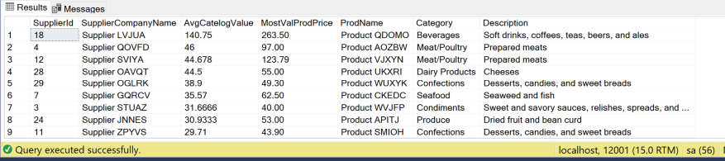

**Sample JSON Output (29 results returned):**

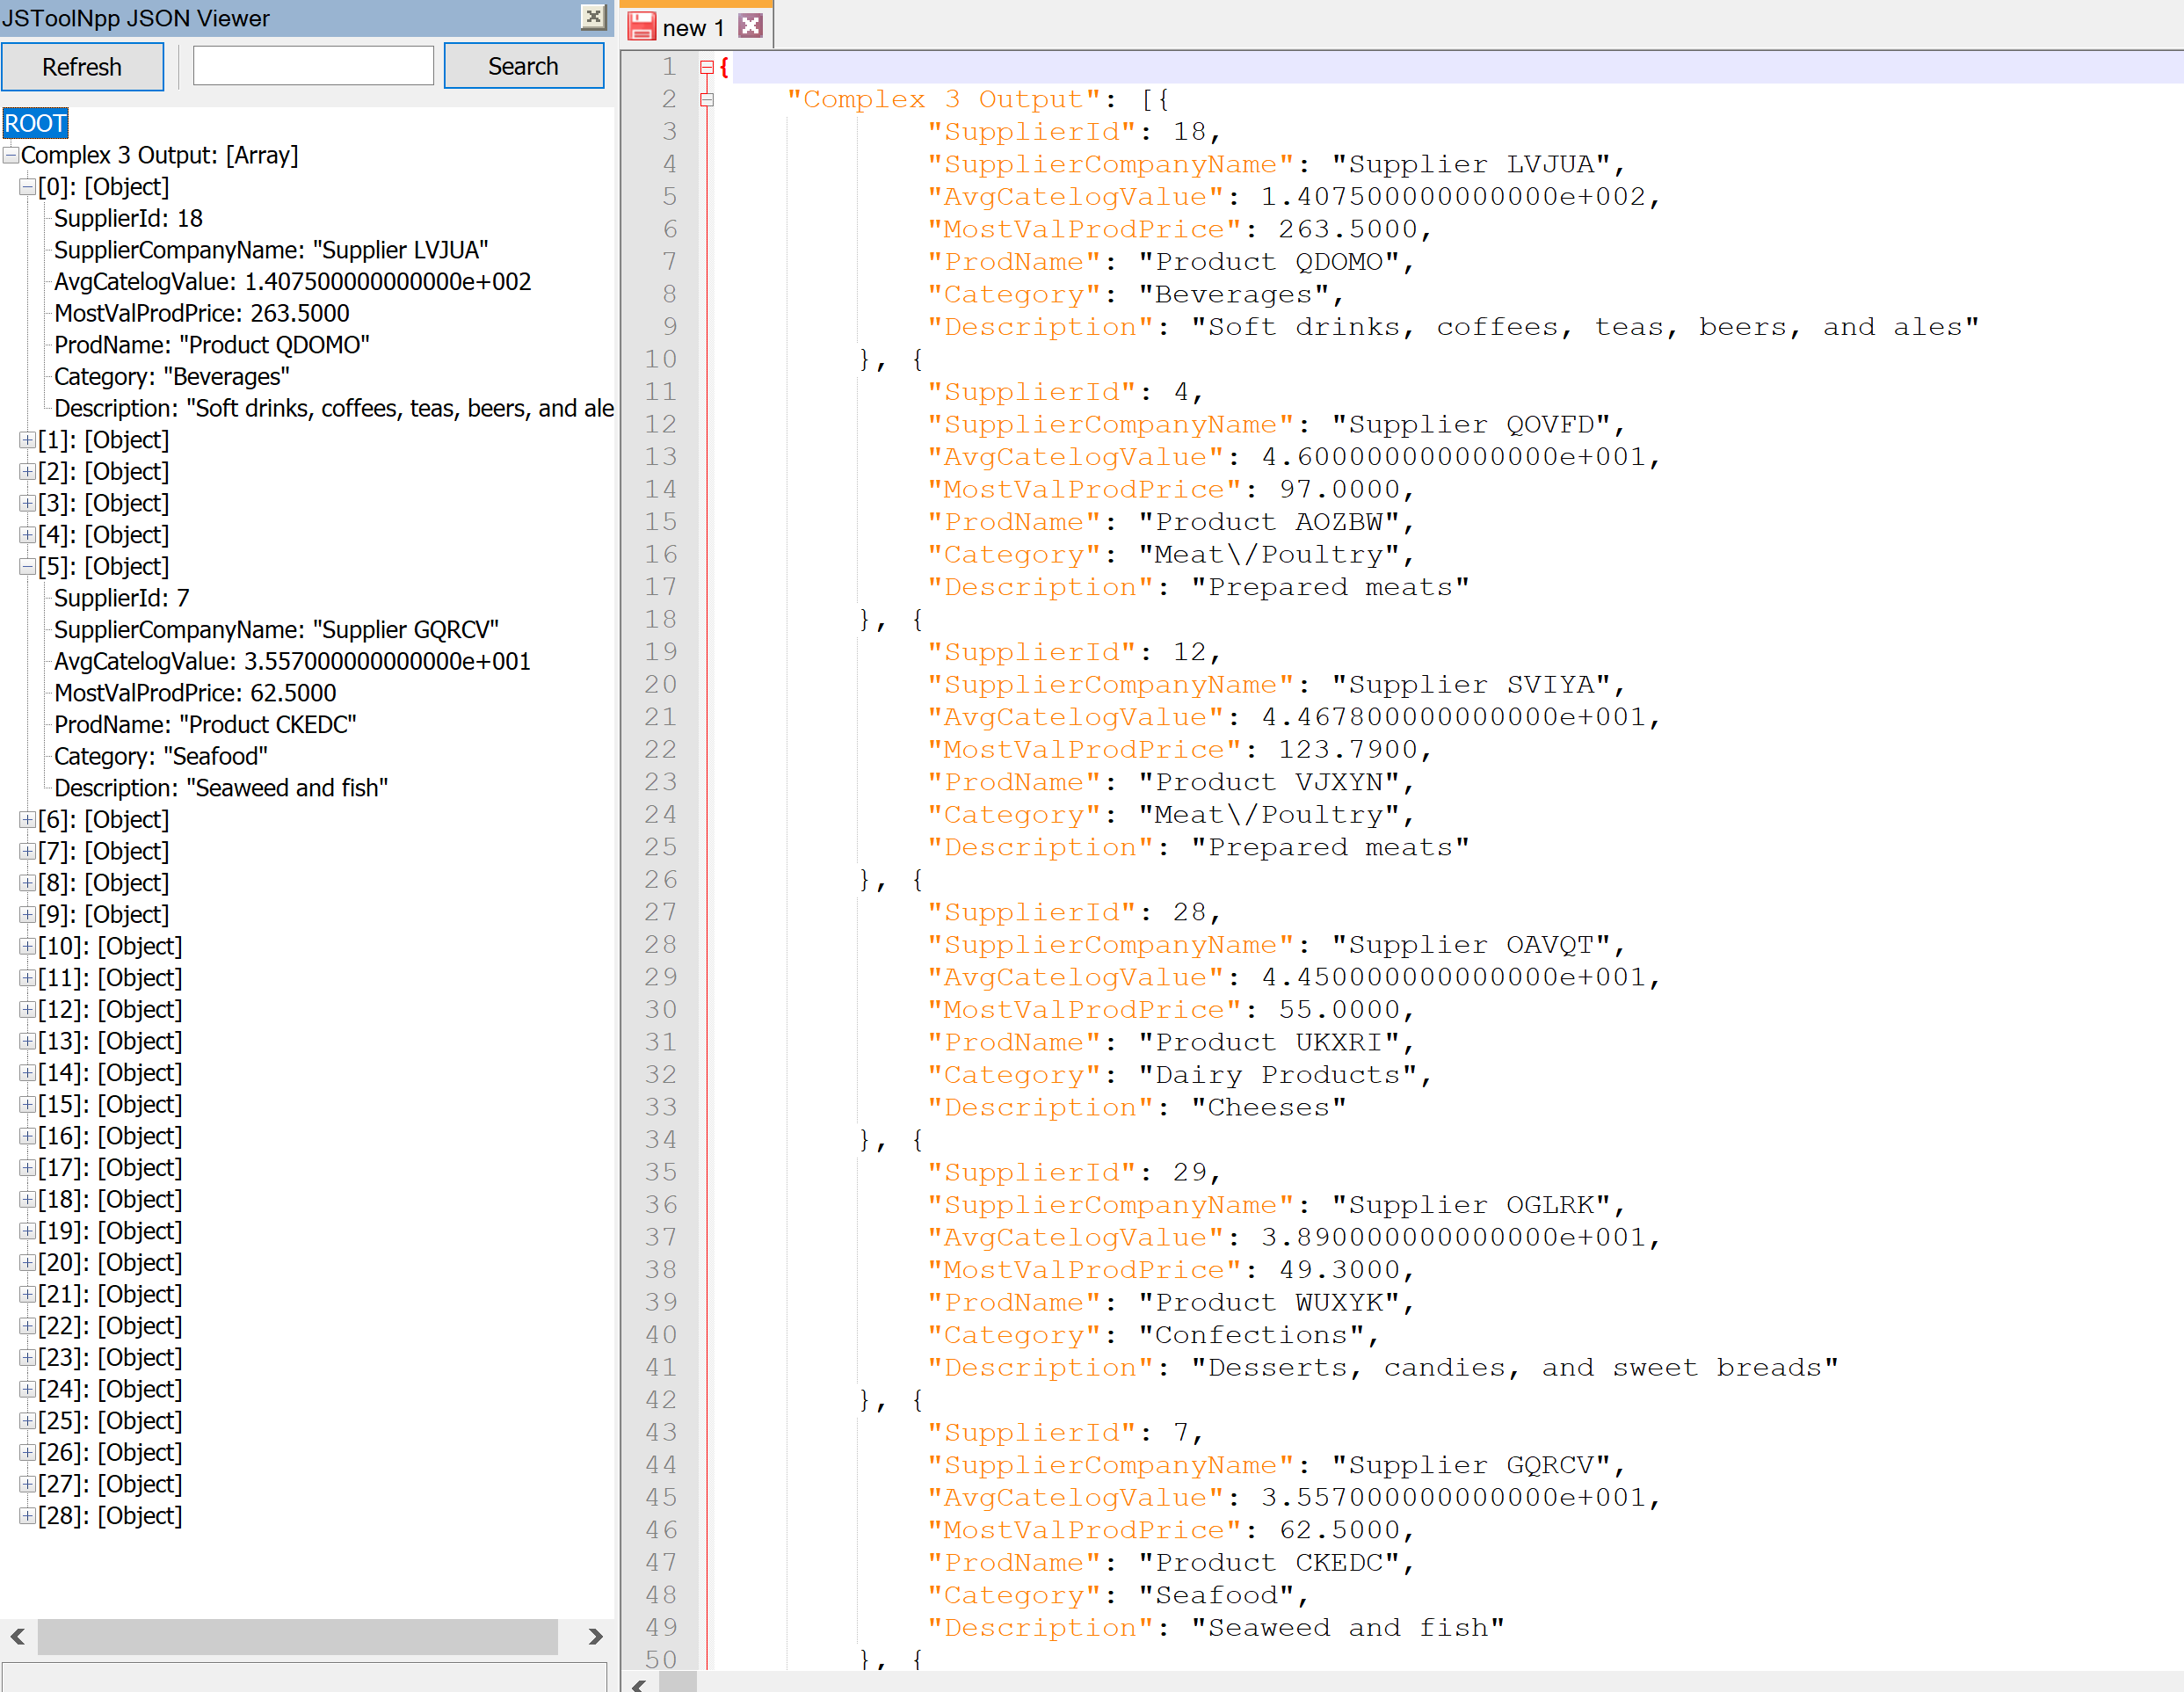

**COMPLEX 4:**

QUERY: This query finds the most productive quarter for each employee based on data from their transactions since the beginning of their employment. This query also compares their total sales to the total sales of the employee specifically from that quarter.

FUNCTIONS: [yearQtr] converts the date to quarter of the year. More specifically, determines what quarter the date is in. [mostProdQtr] returns the quarter in which the employee completed the most orders. [numOrdersProd] returns the number of orders from the employee’s most productive quarter. [totEmpSales] finds the total number of transactions the specified employee has completed.

**Standard View:**

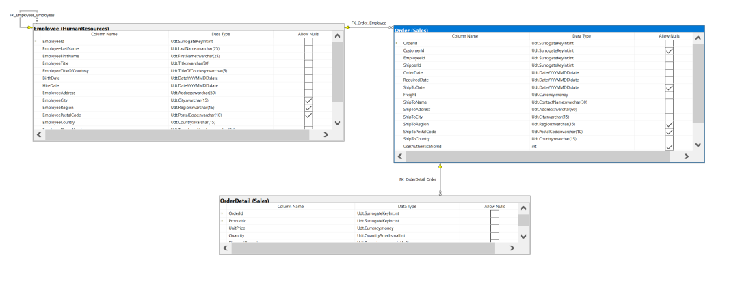

**Key View:**

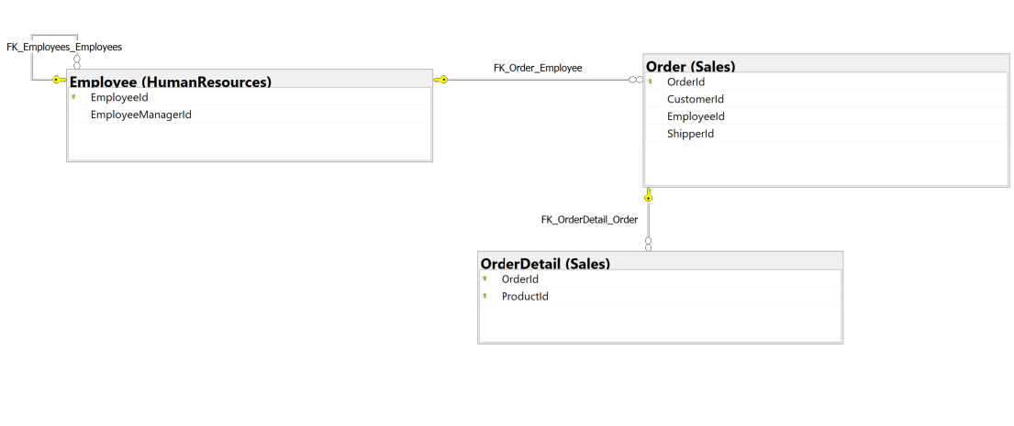

**Columns from tables:**

|  |  |
| --- | --- |
| **Table Name** | **Column Name** |
| HumanResources.Employee | EmployeeId  EmployeeFirstName  EmployeeLastName  EmployeeTitle  MostProdQtr |
| Sales.Order | MPQ_Sales  TotalSales |

**Order By:**

|  |  |  |
| --- | --- | --- |
| **Table Name** | **Column Name** | **Sort Order** |
| Sales.Order | TotalSales | DESC |

**Solution without JSON:**

USE Northwinds2020TSQLV6;

GO

CREATE FUNCTION sales.[yearQtr] (@date DATE)

RETURNS NVARCHAR(10)

AS

BEGIN

DECLARE @val NVARCHAR(10);

DECLARE @month INT;

SET @month = MONTH(@date);

SELECT @val = CASE

WHEN @month BETWEEN 1

AND 3

THEN 'QTR 1'

WHEN @month BETWEEN 4

AND 6

THEN 'QTR 2'

WHEN @month BETWEEN 7

AND 9

THEN 'QTR 3'

WHEN @month BETWEEN 10

AND 12

THEN 'QTR 4'

ELSE 'Unknown QTR'

END

RETURN @val

END

GO

--cleanup

DROP FUNCTION

IF EXISTS Sales.yearQtr;

-------------------------------------------------------------------------------------------------------------------

GO

CREATE FUNCTION sales.[mostProdQtr] (@empl INT)

RETURNS NVARCHAR(10)

AS

BEGIN

DECLARE @val NVARCHAR(10);

SET @val = (

SELECT TOP 1 Sales.yearQtr(ShipToDate)

FROM Sales.[Order]

WHERE employeeid = @empl

GROUP BY Sales.yearQtr(ShipToDate)

ORDER BY count(*) DESC

)

RETURN @val

END

GO

--cleanup

DROP FUNCTION

IF EXISTS Sales.mostProdQtr;

-------------------------------------------------------------------------------------------------------------------

GO

CREATE FUNCTION sales.[numOrdersProd] (@empl INT)

RETURNS INT

AS

BEGIN

DECLARE @val INT;

SET @val = (

SELECT TOP 1 count(*)

FROM Sales.[Order]

WHERE EmployeeId = @empl

GROUP BY Sales.yearqtr(ShipToDate)

ORDER BY COUNT(*) DESC

)

RETURN @val

END

GO

--cleanup

DROP FUNCTION

IF EXISTS Sales.numOrdersProd;

GO

CREATE FUNCTION sales.[totempsales] (@empl INT)

RETURNS INT

AS

BEGIN

DECLARE @val INT;

SET @val = (

SELECT count(*)

FROM Sales.[Order]

WHERE EmployeeId = @empl

)

RETURN @val

END

GO

--cleanup

DROP FUNCTION

IF EXISTS Sales.totempsales;

-------------------------------------------------------------------------------------------------------------------

USE Northwinds2020TSQLV6;

SELECT e.EmployeeId

,e.EmployeeFirstName

,e.EmployeeLastName

,e.EmployeeTitle

,Sales.mostprodqtr(e.EmployeeId) AS MostProdQtr

,Sales.numordersprod(e.EmployeeId) AS MPQ_Sales

,Sales.totempsales(e.EmployeeId) AS TotalSales

FROM Sales.[Order] AS o

INNER JOIN HumanResources.Employee AS e ON o.EmployeeId = e.EmployeeId

GROUP BY e.EmployeeId

,e.EmployeeFirstName

,e.EmployeeLastName

,e.EmployeeTitle

ORDER BY TotalSales DESC

**Solution with JSON:**

USE Northwinds2020TSQLV6;

GO

CREATE FUNCTION sales.[yearQtr] (@date DATE)

RETURNS NVARCHAR(10)

AS

BEGIN

DECLARE @val NVARCHAR(10);

DECLARE @month INT;

SET @month = MONTH(@date);

SELECT @val = CASE

WHEN @month BETWEEN 1

AND 3

THEN 'QTR 1'

WHEN @month BETWEEN 4

AND 6

THEN 'QTR 2'

WHEN @month BETWEEN 7

AND 9

THEN 'QTR 3'

WHEN @month BETWEEN 10

AND 12

THEN 'QTR 4'

ELSE 'Unknown QTR'

END

RETURN @val

END

GO

--cleanup

DROP FUNCTION

IF EXISTS Sales.yearQtr;

-------------------------------------------------------------------------------------------------------------------

GO

CREATE FUNCTION sales.[mostProdQtr] (@empl INT)

RETURNS NVARCHAR(10)

AS

BEGIN

DECLARE @val NVARCHAR(10);

SET @val = (

SELECT TOP 1 Sales.yearQtr(ShipToDate)

FROM Sales.[Order]

WHERE employeeid = @empl

GROUP BY Sales.yearQtr(ShipToDate)

ORDER BY count(*) DESC

)

RETURN @val

END

GO

--cleanup

DROP FUNCTION

IF EXISTS Sales.mostProdQtr;

-------------------------------------------------------------------------------------------------------------------

GO

CREATE FUNCTION sales.[numOrdersProd] (@empl INT)

RETURNS INT

AS

BEGIN

DECLARE @val INT;

SET @val = (

SELECT TOP 1 count(*)

FROM Sales.[Order]

WHERE EmployeeId = @empl

GROUP BY Sales.yearqtr(ShipToDate)

ORDER BY COUNT(*) DESC

)

RETURN @val

END

GO

--cleanup

DROP FUNCTION

IF EXISTS Sales.numOrdersProd;

GO

CREATE FUNCTION sales.[totempsales] (@empl INT)

RETURNS INT

AS

BEGIN

DECLARE @val INT;

SET @val = (

SELECT count(*)

FROM Sales.[Order]

WHERE EmployeeId = @empl

)

RETURN @val

END

GO

--cleanup

DROP FUNCTION

IF EXISTS Sales.totempsales;

-------------------------------------------------------------------------------------------------------------------

USE Northwinds2020TSQLV6;

SELECT e.EmployeeId

,e.EmployeeFirstName

,e.EmployeeLastName

,e.EmployeeTitle

,Sales.mostprodqtr(e.EmployeeId) AS MostProdQtr

,Sales.numordersprod(e.EmployeeId) AS MPQ_Sales

,Sales.totempsales(e.EmployeeId) AS TotalSales

FROM Sales.[Order] AS o

INNER JOIN HumanResources.Employee AS e ON o.EmployeeId = e.EmployeeId

GROUP BY e.EmployeeId

,e.EmployeeFirstName

,e.EmployeeLastName

,e.EmployeeTitle

ORDER BY TotalSales DESC

**Sample Output (9 results returned):**

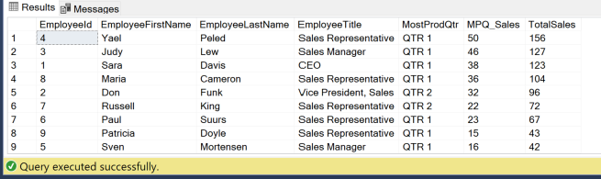

**Sample JSON Output (9 results returned):**

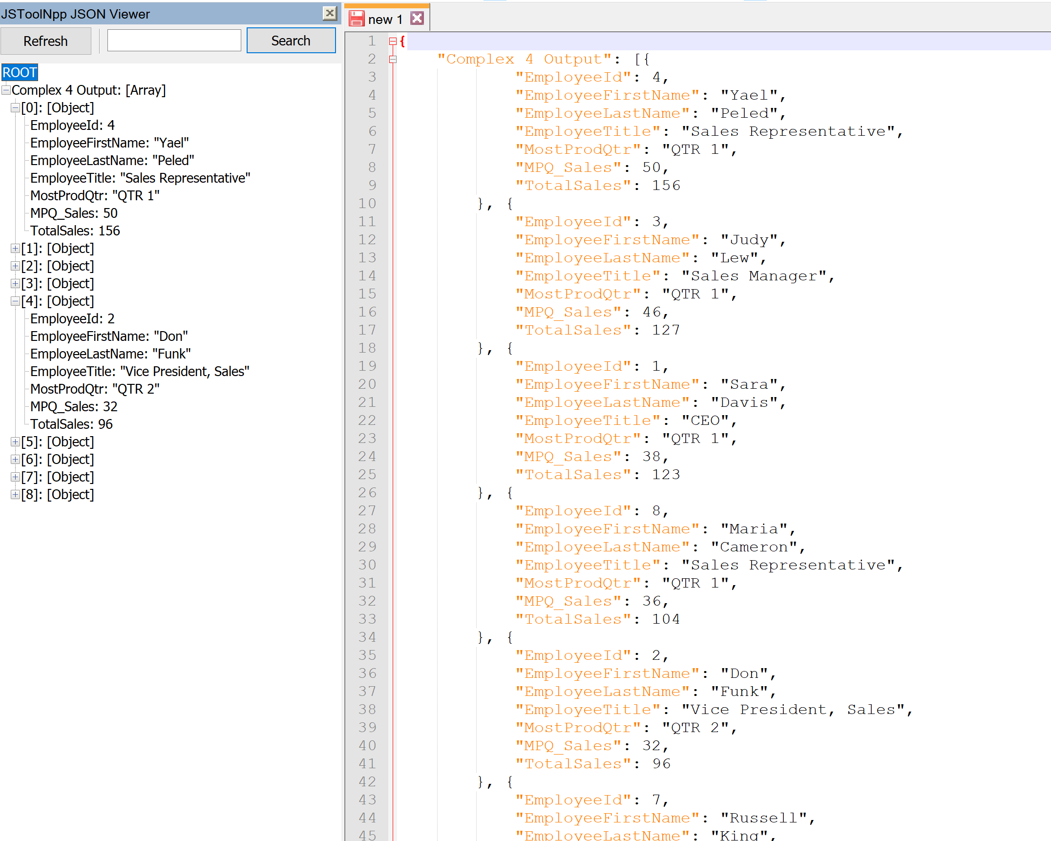

**COMPLEX 5:**

QUERY: This query ranks the best performing products based their total profits and provides some information about each product

FUNCTIONS: [profMarg] returns the profit margins of the specified product for the specified year. [prodProfits] returns the total net profit amount from all transactions of the specified product. [totSales] returns the gross sales amount across all transactions of the specified product.

**Standard View:**

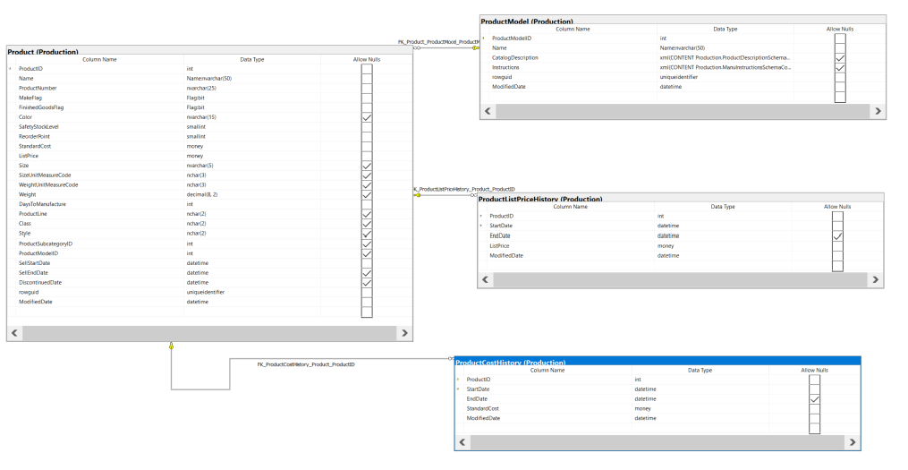

**Key View:**

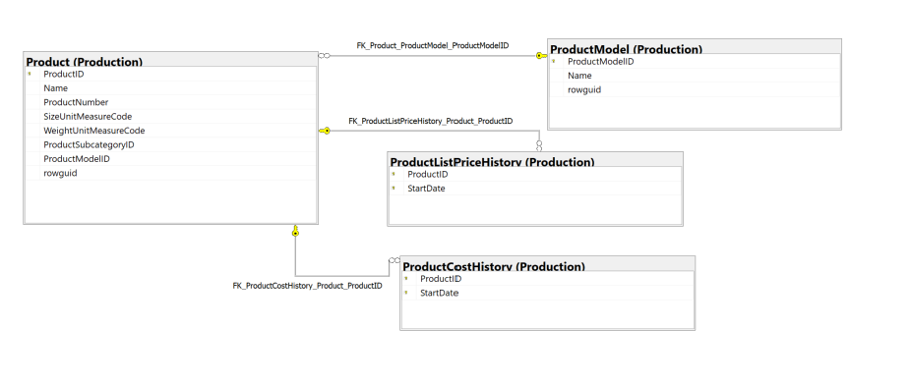

**Columns from tables:**

|  |  |
| --- | --- |
| **Table Name** | **Column Name** |
| Production.Product | ProductId  Name |
| Production.ProductCostHistory | AvgProductionCost |
| Production.ProductListPriceHistory | AvgListPrice |
| Sales.Order | TotalSalesAmt  TotalProfits |

**Order By:**

|  |  |  |
| --- | --- | --- |
| **Table Name** | **Column Name** | **Sort Order** |
| Sales.Order | TotalProfits | DESC |

**Solution without JSON:**

USE AdventureWorks2017;

GO

CREATE FUNCTION production.[profMarg] (

@prodId INT

,@year INT

)

RETURNS FLOAT

AS

BEGIN

DECLARE @cost FLOAT;

DECLARE @price FLOAT;

DECLARE @res FLOAT

SET @cost = (

SELECT StandardCost

FROM Production.ProductCostHistory

WHERE ProductID = @prodId

AND year(StartDate) = @year

)

SET @price = (

SELECT ListPrice

FROM Production.ProductListPriceHistory

WHERE ProductID = @prodId

AND year(StartDate) = @year

)

SET @res = @price - @cost

RETURN @res

END

GO

GO

CREATE FUNCTION production.[prodProfits] (@prodId INT)

RETURNS FLOAT

AS

BEGIN

DECLARE @sum FLOAT;

SET @sum = (

SELECT sum(Production.profMarg(@prodId, year(TransactionDate)) * Quantity)

FROM Production.TransactionHistory

WHERE ProductID = @prodId

AND TransactionType = 'S'

)

RETURN @sum

END

GO

GO

CREATE FUNCTION production.[totSales] (@prodId INT)

RETURNS FLOAT

AS

BEGIN

DECLARE @sum FLOAT;

SET @sum = (

SELECT sum(ActualCost)

FROM Production.TransactionHistory

WHERE ProductID = @prodId

AND TransactionType = 'S'

)

RETURN @sum

END

GO

USE AdventureWorks2017;

SELECT prod.ProductID

,prod.Name

,mod.Name AS Model

,AVG(cost.StandardCost) AS AvgProductionCost

,AVG(price.ListPrice) AS AvgListPrice

,AVG(price.ListPrice) - AVG(cost.StandardCost) AS AvgProfitMargs

,Production.prodProfits(prod.ProductID) AS TotalProfits

,Production.totSales(prod.ProductID) AS TotalSalesAmt

FROM Production.Product AS prod

INNER JOIN Production.ProductModel AS mod ON prod.ProductModelID = mod.ProductModelID

INNER JOIN Production.ProductListPriceHistory AS price ON prod.ProductID = price.ProductID

INNER JOIN Production.ProductCostHistory AS cost ON prod.ProductID = cost.ProductID

GROUP BY prod.ProductID

,prod.Name

,mod.Name

ORDER BY TotalProfits DESC

**Solution with JSON:**

USE AdventureWorks2017;

GO

CREATE FUNCTION production.[profMarg] (

@prodId INT

,@year INT

)

RETURNS FLOAT

AS

BEGIN

DECLARE @cost FLOAT;

DECLARE @price FLOAT;

DECLARE @res FLOAT

SET @cost = (

SELECT StandardCost

FROM Production.ProductCostHistory

WHERE ProductID = @prodId

AND year(StartDate) = @year

)

SET @price = (

SELECT ListPrice

FROM Production.ProductListPriceHistory

WHERE ProductID = @prodId

AND year(StartDate) = @year

)

SET @res = @price - @cost

RETURN @res

END

GO

GO

CREATE FUNCTION production.[prodProfits] (@prodId INT)

RETURNS FLOAT

AS

BEGIN

DECLARE @sum FLOAT;

SET @sum = (

SELECT sum(Production.profMarg(@prodId, year(TransactionDate)) * Quantity)

FROM Production.TransactionHistory

WHERE ProductID = @prodId

AND TransactionType = 'S'

)

RETURN @sum

END

GO

GO

CREATE FUNCTION production.[totSales] (@prodId INT)

RETURNS FLOAT

AS

BEGIN

DECLARE @sum FLOAT;

SET @sum = (

SELECT sum(ActualCost)

FROM Production.TransactionHistory

WHERE ProductID = @prodId

AND TransactionType = 'S'

)

RETURN @sum

END

GO

USE AdventureWorks2017;

SELECT prod.ProductID

,prod.Name

,mod.Name AS Model

,AVG(cost.StandardCost) AS AvgProductionCost

,AVG(price.ListPrice) AS AvgListPrice

,AVG(price.ListPrice) - AVG(cost.StandardCost) AS AvgProfitMargs

,Production.prodProfits(prod.ProductID) AS TotalProfits

,Production.totSales(prod.ProductID) AS TotalSalesAmt

FROM Production.Product AS prod

INNER JOIN Production.ProductModel AS mod ON prod.ProductModelID = mod.ProductModelID

INNER JOIN Production.ProductListPriceHistory AS price ON prod.ProductID = price.ProductID

INNER JOIN Production.ProductCostHistory AS cost ON prod.ProductID = cost.ProductID

GROUP BY prod.ProductID

,prod.Name

,mod.Name

ORDER BY TotalProfits DESC

FOR JSON PATH, ROOT('Complex 5 Output'), INCLUDE_NULL_VALUES;

**Sample Output (293 results returned):**

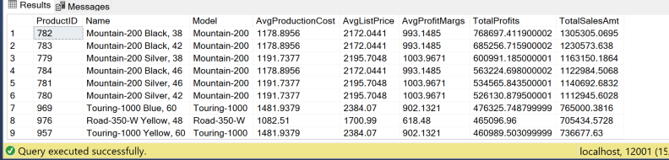

**Sample JSON Output (293 results returned):**

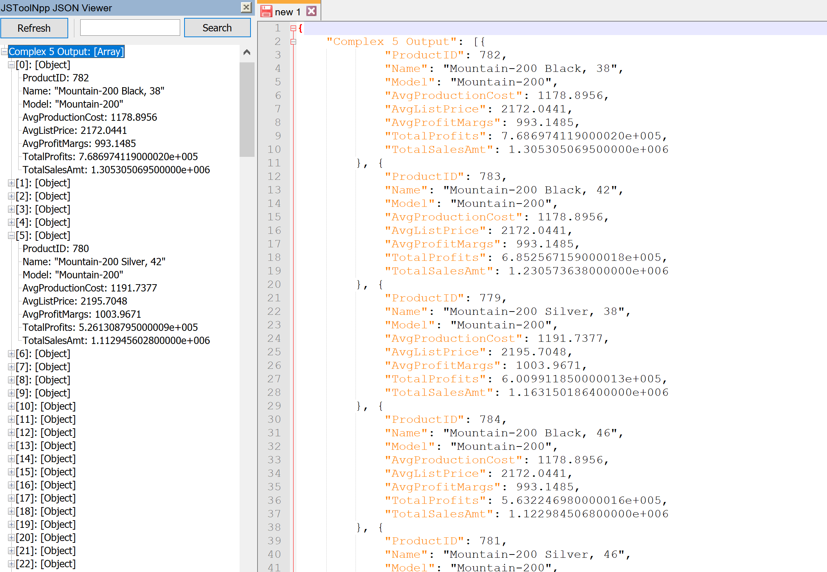

**COMPLEX 6:**

QUERY: This query lists the sales quota for each quarter over 3 years for employee and compares that amount to their actual sales amount during the corresponding time periods.

FUNCTIONS: [dateToQtr] converts the date to quarter. [avgQtrQuota] finds the average quota amount for the specified year and qtr. [actQtrSales] finds the actual sales amount for the specified qtr and year.

**Standard View:**

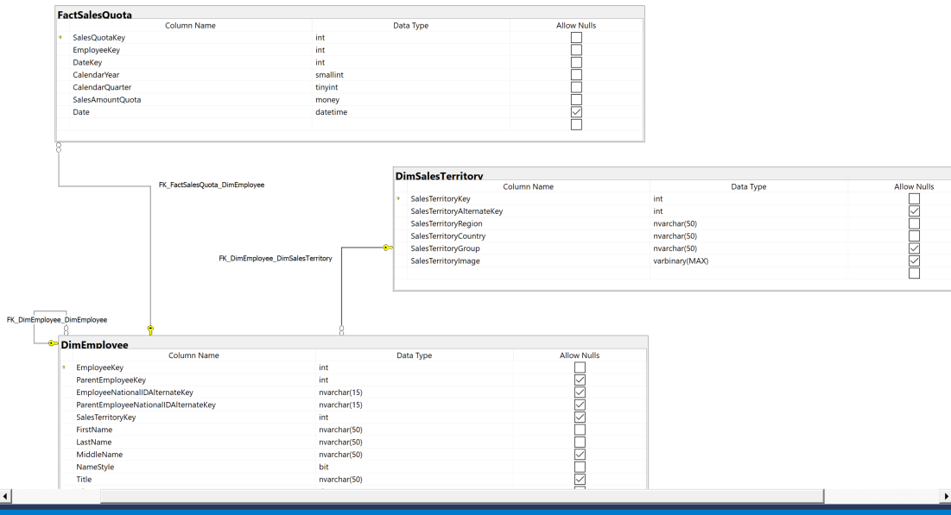

**Key View:**

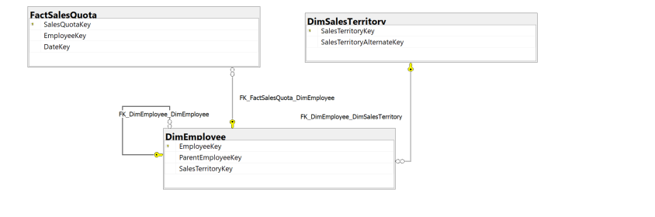

**Columns from tables:**

|  |  |
| --- | --- |
| **Table Name** | **Column Name** |
| Dbo.DimEmployee | EmployeeKey  FirstName  LastName  Title |
| Dbo.DimSalesTerritory | SalesTerritoryCountry |
| Dbo.FactSalesQuota | CalendarYear  CalendarQuarter  QtrQuota |

**Order By:**

|  |  |  |
| --- | --- | --- |
| **Table Name** | **Column Name** | **Sort Order** |
| Dbo.DimEMployee | EmployeeKey | ASC |
| Dbo.FactSalesQuota | CalendarYear  CalendarQuota | ASC |

**Solution without JSON:**

USE AdventureWorksDW2017

GO

CREATE FUNCTION dbo.[dateToQtr] (@date DATE)

RETURNS INT

AS

BEGIN

DECLARE @val INT;

DECLARE @month INT;

SET @month = MONTH(@date);

SELECT @val = CASE

WHEN @month BETWEEN 1

AND 3

THEN 1

WHEN @month BETWEEN 4

AND 6

THEN 2

WHEN @month BETWEEN 7

AND 9

THEN 3

WHEN @month BETWEEN 10

AND 12

THEN 4

ELSE 00000 --unknown qtr

END

RETURN @val

END

GO

GO

CREATE FUNCTION dbo.[avgQtrQuota] (

@empkey INT

,@calyear INT

,@calqtr INT

)

RETURNS FLOAT

AS

BEGIN

DECLARE @val FLOAT;

SET @val = (

SELECT avg(SalesAmountQuota)

FROM dbo.FactSalesQuota

WHERE EmployeeKey = @empkey

AND CalendarYear = @calyear

AND CalendarQuarter = @calqtr

)

RETURN @val;

END

GO

GO

CREATE FUNCTION dbo.[actQtrSales] (

@empkey INT

,@calyear INT

,@calqtr INT

)

RETURNS FLOAT

AS

BEGIN

DECLARE @val FLOAT;

SET @val = (

SELECT sum(SalesAmount)

FROM dbo.FactResellerSales

WHERE EmployeeKey = @empkey

AND year(ShipDate) = @calyear

AND dbo.dateToQtr(ShipDate) = @calqtr

)

RETURN @val;

END

GO

USE AdventureWorksDW2017

SELECT emp.EmployeeKey

,emp.FirstName

,emp.LastName

,emp.Title

,terr.SalesTerritoryCountry

,quota.CalendarYear

,quota.CalendarQuarter

,avg(quota.SalesAmountQuota) AS QtrQuota

,dbo.actQtrSales(emp.EmployeeKey, quota.CalendarYear, quota.CalendarQuarter) AS QuarterSales

FROM dbo.FactSalesQuota AS quota

INNER JOIN dbo.DimEmployee AS emp ON emp.EmployeeKey = quota.EmployeeKey

INNER JOIN dbo.DimSalesTerritory AS terr ON terr.SalesTerritoryKey = emp.SalesTerritoryKey

WHERE quota.CalendarYear != 2010

GROUP BY quota.CalendarYear

,quota.CalendarQuarter

,emp.EmployeeKey

,emp.FirstName

,emp.LastName

,emp.Title

,terr.SalesTerritoryCountry

ORDER BY emp.EmployeeKey

,quota.CalendarYear

,quota.CalendarQuarter

**Solution with JSON:**

USE AdventureWorksDW2017

GO

CREATE FUNCTION dbo.[dateToQtr] (@date DATE)

RETURNS INT

AS

BEGIN

DECLARE @val INT;

DECLARE @month INT;

SET @month = MONTH(@date);

SELECT @val = CASE

WHEN @month BETWEEN 1

AND 3

THEN 1

WHEN @month BETWEEN 4

AND 6

THEN 2

WHEN @month BETWEEN 7

AND 9

THEN 3

WHEN @month BETWEEN 10

AND 12

THEN 4

ELSE 00000 --unknown qtr

END

RETURN @val

END

GO

GO

CREATE FUNCTION dbo.[avgQtrQuota] (

@empkey INT

,@calyear INT

,@calqtr INT

)

RETURNS FLOAT

AS

BEGIN

DECLARE @val FLOAT;

SET @val = (

SELECT avg(SalesAmountQuota)

FROM dbo.FactSalesQuota

WHERE EmployeeKey = @empkey

AND CalendarYear = @calyear

AND CalendarQuarter = @calqtr

)

RETURN @val;

END

GO

GO

CREATE FUNCTION dbo.[actQtrSales] (

@empkey INT

,@calyear INT

,@calqtr INT

)

RETURNS FLOAT

AS

BEGIN

DECLARE @val FLOAT;

SET @val = (

SELECT sum(SalesAmount)

FROM dbo.FactResellerSales

WHERE EmployeeKey = @empkey

AND year(ShipDate) = @calyear

AND dbo.dateToQtr(ShipDate) = @calqtr

)

RETURN @val;

END

GO

USE AdventureWorksDW2017

SELECT emp.EmployeeKey

,emp.FirstName

,emp.LastName

,emp.Title

,terr.SalesTerritoryCountry

,quota.CalendarYear

,quota.CalendarQuarter

,avg(quota.SalesAmountQuota) AS QtrQuota

,dbo.actQtrSales(emp.EmployeeKey, quota.CalendarYear, quota.CalendarQuarter) AS QuarterSales

FROM dbo.FactSalesQuota AS quota

INNER JOIN dbo.DimEmployee AS emp ON emp.EmployeeKey = quota.EmployeeKey

INNER JOIN dbo.DimSalesTerritory AS terr ON terr.SalesTerritoryKey = emp.SalesTerritoryKey

WHERE quota.CalendarYear != 2010

GROUP BY quota.CalendarYear

,quota.CalendarQuarter

,emp.EmployeeKey

,emp.FirstName

,emp.LastName

,emp.Title

,terr.SalesTerritoryCountry

ORDER BY emp.EmployeeKey

,quota.CalendarYear

,quota.CalendarQuarter

**Sample Output (143 results returned):**

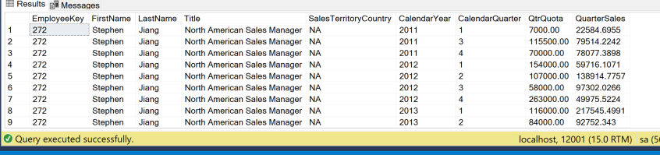

**Sample JSON Output (143 results returned):**

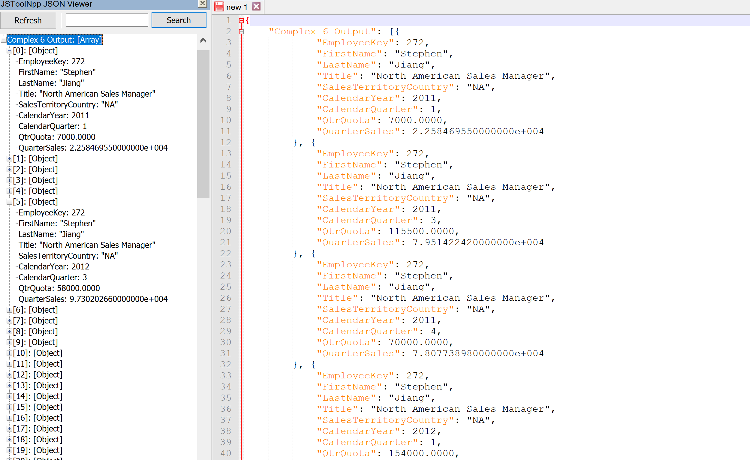

**COMPLEX 7:**

QUERY: This query ranks products based on the amount sold by reseller and sold online and gives some information about each product.

FUNCTIONS: [numProdSold] finds the total amount of sales for the specified product online and by resellers

**Standard View:**

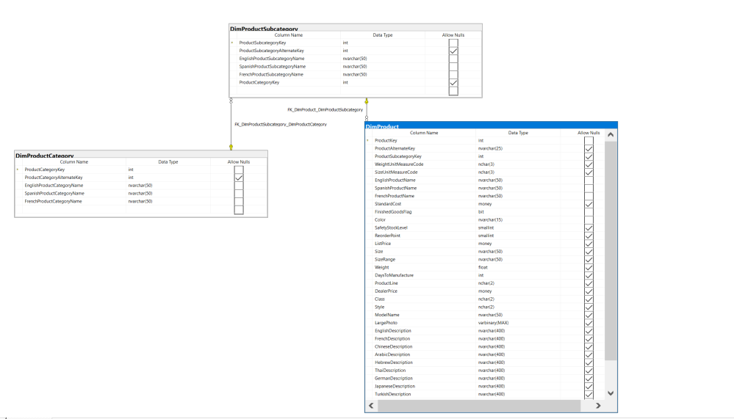

**Key View:**

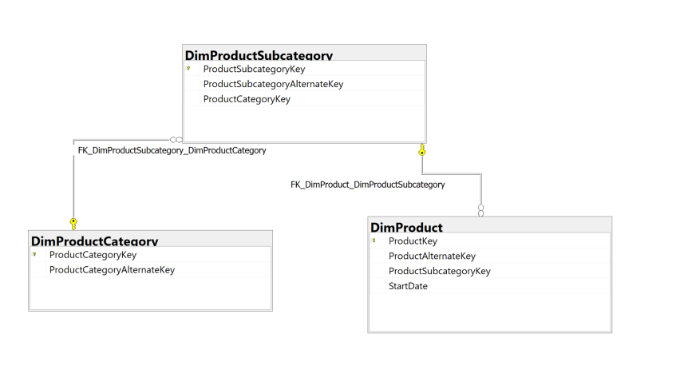

**Columns from tables:**

|  |  |
| --- | --- |
| **Table Name** | **Column Name** |
| Dbo.DimProduct | ProductKey  EnglishProductName  ListPrice  TotalUnitsSold |
| Dbo.DimProductCategory | EnglishProductCategoryName |
| Dbo.DimProductSubcategory | EnglishProductSubcategoryName |

**Order By:**

|  |  |  |
| --- | --- | --- |
| **Table Name** | **Column Name** | **Sort Order** |
| Dbo.DimProduct | TotalUnitsSold | DESC |

**Solution without JSON:**

USE AdventureWorksDW2017;

GO

CREATE FUNCTION dbo.[numProdSold] (@prodId INT)

RETURNS INT

AS

BEGIN

DECLARE @val INT;

DECLARE @sum1 INT;

DECLARE @sum2 INT;

SET @sum1 = (

SELECT sum(OrderQuantity)

FROM dbo.FactInternetSales

WHERE ProductKey = @prodId

)

SET @sum2 = (

SELECT sum(OrderQuantity)

FROM dbo.FactResellerSales

WHERE ProductKey = @prodId

)

SET @val = @sum1 + @sum2

RETURN @val;

END

GO

USE AdventureWorksDW2017;

SELECT prod.ProductKey

,prod.EnglishProductName

,subcat.EnglishProductSubcategoryName

,cat.EnglishProductCategoryName

,prod.ListPrice

,dbo.numProdSold(prod.ProductKey) AS TotalUnitsSold

FROM dbo.DimProductSubcategory AS subcat

INNER JOIN dbo.DimProduct AS prod ON prod.ProductSubcategoryKey = subcat.ProductSubcategoryKey

INNER JOIN dbo.DimProductCategory AS cat ON subcat.ProductCategoryKey = cat.ProductCategoryKey

GROUP BY prod.ProductKey

,prod.EnglishProductName

,subcat.EnglishProductSubcategoryName

,cat.EnglishProductCategoryName

,prod.ListPrice

ORDER BY TotalUnitsSold DESC

**Solution with JSON:**

USE AdventureWorksDW2017;

GO

CREATE FUNCTION dbo.[numProdSold] (@prodId INT)

RETURNS INT

AS

BEGIN

DECLARE @val INT;

DECLARE @sum1 INT;

DECLARE @sum2 INT;

SET @sum1 = (

SELECT sum(OrderQuantity)

FROM dbo.FactInternetSales

WHERE ProductKey = @prodId

)

SET @sum2 = (

SELECT sum(OrderQuantity)

FROM dbo.FactResellerSales

WHERE ProductKey = @prodId

)

SET @val = @sum1 + @sum2

RETURN @val;

END

GO

USE AdventureWorksDW2017;

SELECT prod.ProductKey

,prod.EnglishProductName

,subcat.EnglishProductSubcategoryName

,cat.EnglishProductCategoryName

,prod.ListPrice

,dbo.numProdSold(prod.ProductKey) AS TotalUnitsSold

FROM dbo.DimProductSubcategory AS subcat

INNER JOIN dbo.DimProduct AS prod ON prod.ProductSubcategoryKey = subcat.ProductSubcategoryKey

INNER JOIN dbo.DimProductCategory AS cat ON subcat.ProductCategoryKey = cat.ProductCategoryKey

GROUP BY prod.ProductKey

,prod.EnglishProductName

,subcat.EnglishProductSubcategoryName

,cat.EnglishProductCategoryName

,prod.ListPrice

ORDER BY TotalUnitsSold DESC

FOR JSON PATH, ROOT('Complex 7 Output'), INCLUDE_NULL_VALUES;

**Sample Output (397 results returned):**

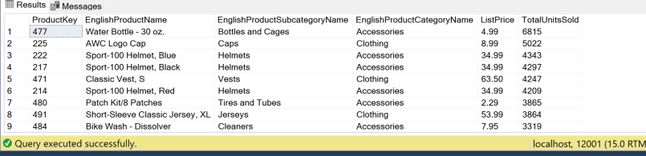

**Sample JSON Output (397 results returned):**

